**PRIMARY SIX INTEGRATED SCIENCE LESSON NOTES**

**TERM ONE**

# THEME: WORLD OF LIVING THINGS

**TOPIC: CLASSIFICATION OF ANIMALS**

**LESSON :1**

**CLASSIFICATION OF VERTEBRATES**.

**Classification of living things (basic characteristics)**

* Classification means grouping of organisms according to their characteristics.
* **Basic characteristics of living things are:**

1. They reproduce.
2. They respond to stimuli
3. They respire
4. They feed
5. They grow
6. The excrete
7. They move/locomote

**Groups of animals**

* Animals in the environment are grouped into **vertebrates** and **invertebrates.**
* Vertebrates are animals with a back bone/vertebral column/spine.

**Characteristics of vertebrates.**

1. Vertebrates have a back bone
2. Vertebrates have endo skeleton.
3. They have a water proof skin.

**Classification of vertebrates.**

Vertebrates are classified or grouped into two groups namely;

1. Warm blooded vertebrates

* Birds
* Mammals

1. Cold blooded vertebrates

* Reptiles
* Fish
* Amphibians
* **Warm blooded animals** are vertebrates that keep their body temperatures constant or slightly change.

**Examples**

All birds and mammals

* **Cold blooded animals** are vertebrates that change their body temperatures according to the environment.

**Examples**

Lizards, snakes, crocodiles, frogs, toads and fish

1. **Learners’ Activity** List any four characteristics of living things
2. In one sentence explain the term vertebrates
3. Identify any one characteristic common to all vertebrates.
4. Write one sentence to explain the following terms;
5. Warm blooded animals
6. Cold blooded animals
7. Give two examples of cold blooded animals
8. In one sentence give a reason why animals move.

**SUB TOPIC: WARM BLOODED VERTERBRATES**

**LESSON 2 : BIRDS (CHARATERISTICS OF BIRDS)**

A bird is warm blooded vertebrate covered with feathers, two wings, two legs and a beak.

**Characteristics of birds**

* They are warm blooded vertebrates.
* Their legs are covered with scales and the body with feathers.
* They reproduce by means of laying eggs which are fertilized internally
* They breathe using lungs.
* They are stream lined/pointed at the front and the back to overcome friction (viscosity)
* They have a four chambered heart.
* Birds use beaks for pecking food.
* Birds care for their young ones
* They have endo skeleton.
* Birds have back bones

**NOTE 1:** birds use their front limbs modified as wings for flying and the hind limbs for walking.

An illustration showing the external parts of a bird.

**NOTE 2:**Their skin is dry, loose and has no sweat glands so cooling is effected by panting.

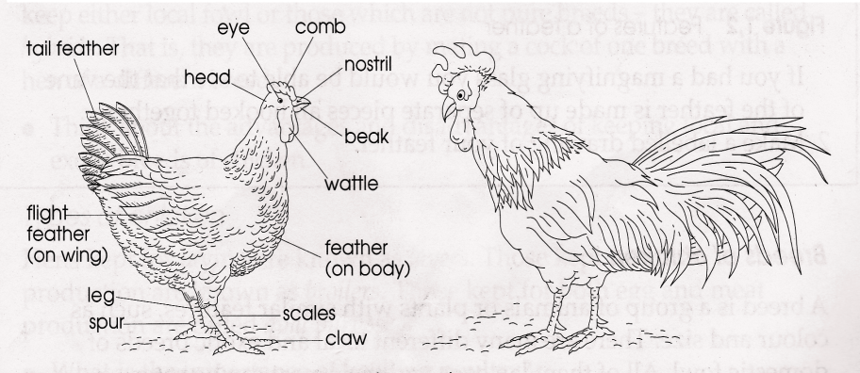

**Note 3:**

A bird has spurs on the legs for protection/defence.

* Birds use feathers for protection of the inner body parts from external damage.
* Feathers of birds provide warmth to the body of the bird.
* Feathers help the bird to fly especially those of the wings and tail.

1. **Learners Activity**  Give any four characteristics of birds
2. In one sentence give the functions of the following parts of the bird
3. Talons c) feathers
4. Beak
5. State how birds reproduce
6. Draw and name the following parts of a hen
7. Spur
8. Wattle
9. Eye
10. In one sentence give two differences between a hen and a cock

**TOPIC C: WARM BLOODED VERTEBRATES**

**LESSON 3: BIRDS (BIRD FEATHERS)**

**Types of bird feathers;**

* There are basically four types namely;

1. Quill or flight feathers
2. Body or covert feathers
3. Down feathers
4. Filoplume feathers.

**NOTE**; Quill feathers are divided into primary and secondary feathers.

* Quill feathers have a strong central part called the shaft, the hollow portion. They are found on the tail and wings.
* Covert feathers help to cover the body of the bird
* Covert feathers are slightly smaller compared to Quill feathers.
* Filoplume feathers are the smallest and found nearest the skin of the bird.
* Down feathers help to trap a layer of air close to the body therefore keeping the bird’s body warm.

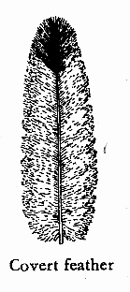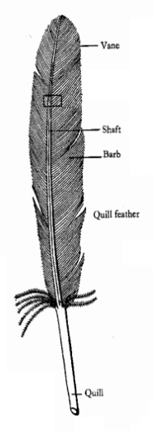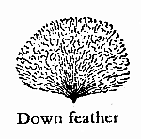

**A Quill feather**

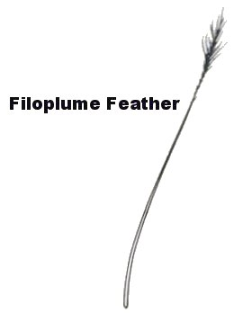

1. **Learners’ activity 3.** State the importance of feathers to a bird
2. Identify the four types of feathers
3. Below is a diagram of a bird’s feather. Use it to answer the questions that follow.

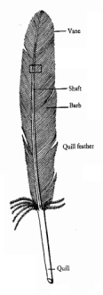

A

B

C

1. Identify the type of feather shown in the diagram
2. Name parts marked with letters A, B, C
3. In which way is the quill feather useful to a bird?

**SUBTOPIC: VERTERBRATES**

**LESSON 4; BIRDS (REPRODUCTION IN BIRDS)**

**Content;**

**Reproduction in birds**

* Birds reproduce by means of laying eggs.
* Their eggs are fertilized internally before they are laid out.
* A hen will sit on the eggs (incubate) until they hatch into young ones (chick)

**An illustration showing parts of a fertilized egg.**

Germinal disc

Egg shell

Albumen

Egg membrane

Twisted Chalaza

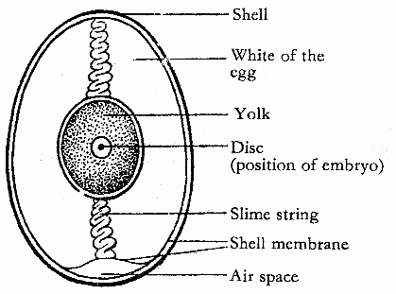

**Functions of the parts.**

**Egg shell**: protects the inner part of an egg.

It is porous to allow free circulation of air.

**Air space**: keeps and provides oxygen to the embryo.

**Egg Yolk**; provides carbohydrates/salts, fats to the grown embryo.

**Embryo:** develops into a chick under favourable conditions.

**Albumen;** Provides water and mineral salts to the growing embryo.

**Chalaza;** holds the Yolk and embryo in one position.

1. **Learners’ activity** Which type of fertilization occurs in birds
2. The diagram below shows a fertilized egg. Use it to answer the questions that follow.

m

r

t

s

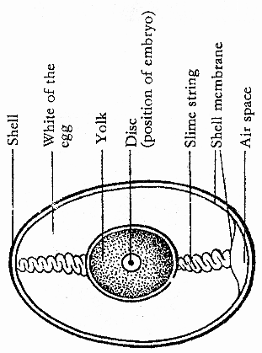

1. Name parts of an egg marked r,t
2. State the functions of each of the following parts
3. s ii) m
4. What class of food is obtained from eating eggs?

**SUBTOPIC: VERTEBRATES.**

**LESSON 5: GROUPS OF BIRDS. (Birds of prey and scavenger birds**

**Characteristics of birds of prey**

* Have strong sharp hooked beak for tearing their prey
* Have strong curved talons for easy gripping of their prey.
* Have a strong eye sight to locate their prey.

**A Beak of a bird of prey A foot of a bird of prey**

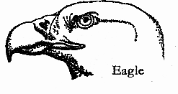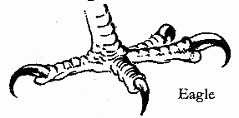

Strong, sharp and hooked beak Short curved talons for easy gripping of prey

**Scavenger birds.**

* Are birds which feed on flesh killed by other animals
* Scavenger birds are useful in the environment because they keep the environment clean by eating flesh of dead animals which may rot or smell.

**Examples:** crows, vultures, marabou storks

Examples of prey; smaller birds; chicks, frogs toads, tortoises/ turtles etc

**Dangers of birds of prey to people**

They eat people’s chicks, rabbits.

**Diagram showing a beak and foot of scavenger bird**

**Beak Foot**

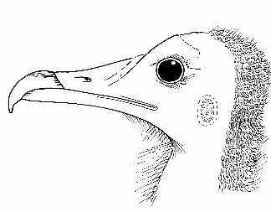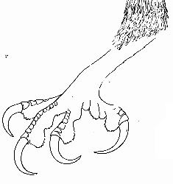

Strong, sharp and hooked beak Longer sharp, curved talons which grip fresh of the remains.

**Note:** scavenger birds have beaks similar to the birds of prey.

Compare the beaks of a bird of prey and a parrot.

1. **Learners’ Activity** State any one example of a scavenger birds
2. State the way a scavenger bird differs from a preying bird
3. How useful are scavenger birds in our environment
4. Apart from birds, name any other example of scavenger animals

5.State the meaning of the term scavenger birds

**SUBTOIC: VERTEBRATES**

**LESSON 6: GROUPS OF BIRDS (PERCHING BIRDS, SCRATCHING BIRDS AND CLIMBING BIRDS )**

**Perching birds:**

These are birds that perch on branches of trees.

Have one toe pointing backwards and three toes pointing forward

**Note**: Perching birds are grouped according to their habits and feeding.

These are seed eater, fruit eaters, insect eaters and nectar suckers.

**Seed eaters:** these have short conical beaks for easy splitting of seeds.

Examples include, pigeons, dove, weaver birds, finches, and parrot.

**A structure of a head of a parrot**

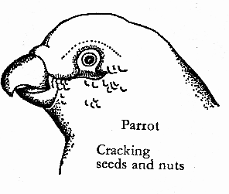

**Insect eaters**: These have short narrow beaks for easy picking up of the insects from barks of trees.

Examples include robins, sparrows, swift, swallows.

**Note**: Insect eaters have the ability to catch their prey on flight.

Structures showing a robin and sparrow birds.

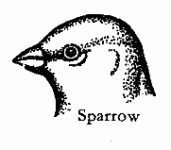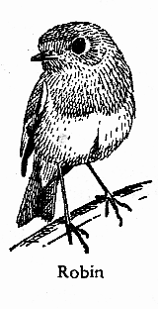

**Content**  **Nectar suckers**; these have long slender beaks for easy sucking of nectar from flowers.

Examples are; the sun bird and humming bird.

An illustration showing a beak of a sun bird.

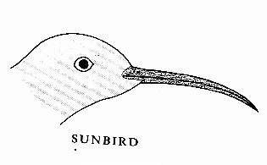

**Fruits eaters:** These have long stout beaks for collecting fruits from trees.

* They are also called foresters and help in seed or fruit disposal.
* A horn bill is the best example of a fruit eater

**Scratching birds**

* These are birds which scratch earth to find their food.
* Such birds get worms, small insects and seeds from soil.

**Characteristic of scratching birds.**

* They have strong feet with thick toes and blunt talons.
* They have strong pointed beaks for picking up things from the ground.

**An illustration showing a beak and foot of a scratching bird.**

Strong foot thick toes and blunt claws Strong short pointed beak for picking up food from soil

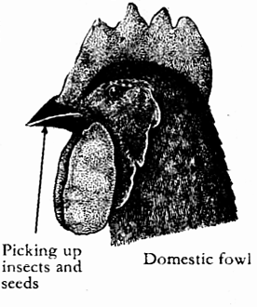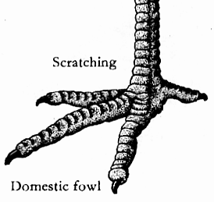

**Climbing birds**

* These are birds with two toes pointing forward and two pointing backwards.
* The toe arrangement helps them to climb trees looking for seeds and insects.
* They commonly live in trees and run about on branches of trees.

An illustration showing the toes of a climbing bird.

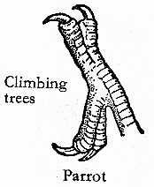

Two toes forward and two toes backwards.

**Examples include** parrots and wood pecker. They are the best examples of climbing birds.

1. **Learners’ Activity** In a sentence explain the meaning of the term perching birds
2. Identify any two characteristics of the perching birds
3. Give two ways in which perching birds are useful to a crop farmer
4. In one sentence describe the following groups of perching birds:
5. Seed eaters
6. Insect eaters
7. Fruit eaters
8. Nectar suckers
9. Give any one example of a nectar sucker
10. In one sentence describe how perching birds feed.
11. List the examples of scratching and climbing birds

**SUBTOPIC: VRTEBRATES (BIRDS)**

**LESSON 7: SWIMMING BIRDS**

* **content** These are birds with webbed feet for padding in water they swim
* Examples include, swan, duck, goose, penguin, sea gull, pelican.
* They have a spoon shaped beak for easy sieving of their food from mud/water.
* They have a layer of fats to keep them warm in water.
* They are commonly seen in water looking for their food.

**An illustration showing the foot and a beak of a swimming bird.**

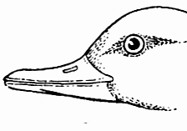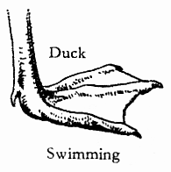

A webbed foot for padding in water Spoon shaped beak for easy sieving of food from water/mud.

1. **Learners’ Activity** What is meant by the term swimming birds?
2. List any two examples of swimming birds
3. State two ways in which swimming birds are adapted to their mode of life
4. In the space below draw a foot of a swimming bird

**SUBTOPIC: VERTEBRATES (BIRDS)**

**LESSON 8: WADING AND FLIGHTLESS BIRDS**

**Content**

**Wading birds;**

* Wading birds are birds that walk through water or wade mainly to find their food.

Wading birds have the following characteristics.

1. Have long beaks for easy hunting of small fish, frogs and worms from water for food.

**Examples of wading birds.**

Ibis, heron, eaglet, crested crane, flamingo birds, storks.

1. Have long thin legs with half webbed toes widely spread out to prevent them from sinking in water.

**An illustration showing a beak and a foot of wading bird.**

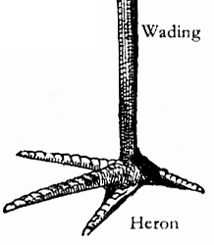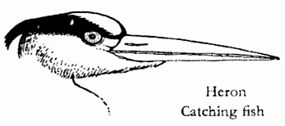

A beak for a wading: bird long and strong Half – webbed toes to prevent sinking in water

**Flightless birds**.

* These are birds which cannot fly but run very fast.
* Their bodies are heavier compared to the wings hence unable to fly.
* They have a lot of bone marrow hence heavier to fly in air with their weaker and smaller wings.

**Examples of flightless birds includes**;

Ostrich, kiwi, emu, penguin, cassowary

**Note:** ostriches are commonly kept in the zoo and their eggs are edible.

**A structure showing an ostrich**

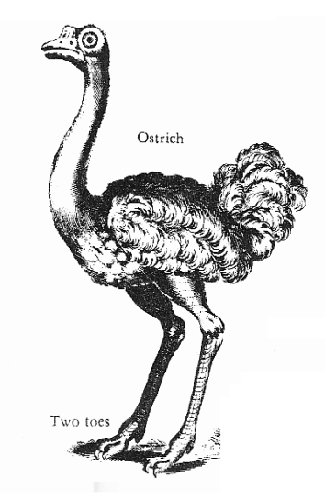

Weak and small wings compared to the body size.

1. **Learners’ Activity** In one sentence state the meaning of the following terms:
2. Wading birds
3. Flightless birds
4. Give two examples of;
5. Wading birds
6. Flightless birds
7. Name the flightless bird commonly kept in the zoo.

**SUBTOPIC: VERTEBRATES (BIRDS)**

**LESSON 9: ADAPTATIONS OF BIRDS TO THEIR MODE OF LIFE**

**Adaptation of birds to their mode of life.**

Adaptation means the features that make an organism suit a characteristic or behavior.

**Adaptation of birds to their mode of life include:**

Their front limbs are modified into wings for easy flight.

* Most have hollowed bones to reduce their body weight for easy flying.
* They have a stream lined body to overcome viscosity during flight.
* They have no pinna to obstruct the flow of air on flight.
* Their bodies are covered with feathers to provide warmth and colour to the bird.
* They have a nictitating membrane which protects their eyes against foreign bodies into the eye on flight.

**Advantages of birds to people**

* Birds provide people with meat and eggs as food.
* Some birds such as sun bird help in plant pollination.
* Some birds (scavengers) help to keep the environment clean
* Domestic birds are a source of income once sold.

**Disadvantages of birds in the environment.**

* Many birds spoil farmer’s crops i.e getting raw materials to make their nests, feed on crops etc.
* Birds cause noise pollution especially weaver birds in the environment.
* Bird feathers keep vectors to human health like fleas and mites.

1. **Learners’ Activity** State any four ways in which birds are adapted to their mode of life
2. In four sentences state the importance of birds to people
3. State how birds can be dangerous in our environment

**SUBTOPIS: VERTEBRATES (mammals)**

**LESSON 10: CHARACTRISTICS OF MAMMALS**.

**Mammals;** These are worm blooded vertebrates whose skin is colored with hair.

**General Characteristics of mammals include**;

* They have mammary glands
* They have well developed ear lobes to trap sound waves.
* They have fur on their bodies.
* They breathe through the lungs.
* They have four chambered hearts.\most mammals give birth to their young ones alive except the egg laying mammals
* They have back bones.
* All mammals are warm blooded.

**Specific characteristics of mammals**

* Their bodies are covered with fur
* They have mammary glands
* They feed their young ones on breast milk produced by the mammary glands.

**Classification of mammals**.

Mammals are grouped into nine sub classes according to their features and behavior.

**These are;**

* Primates (most advances mammals)
* Rodents (gnawing mammals)
* Ungulates (hoofed mammals)
* Chiroptera (flying mammals)
* Monotremes (egg laying mammals)
* Carnivores (flesh eaters)
* Marsupials (pouched mammals)
* Insectivores (insect eating mammals)

1. **Learners’ Activity** In a sentence explain the term mammal
2. Give a reason why mammals are referred to as vertebrates
3. List the different groups of mammals
4. In one sentence give a reason why a kangaroo is regarded as a mammal

**SUBTOPIC: VERTEBRATES (MAMMALS)**

**LESSON 11: PRIMATES AND MONOTREMES**

**Primates (most advanced mammals)**

* Primates are the most advanced subclass of mammals.
* They have a well developed set of teeth (32)
* Primates have an advanced brain.

**Characteristics of primates.**

* They have five fingers and five toes on each foot.
* They use their front limbs for holding things while hind limbs for walking.
* All primates are omnivores feed on both flesh and vegetables)

**Examples of primates includes**;

People, gorillas, chimpanzee, baboon, bush baby, monkey, apes, gibbon

**Drawn structures showing a bush baby, a monkey and a gorilla.**

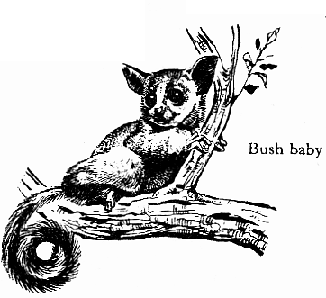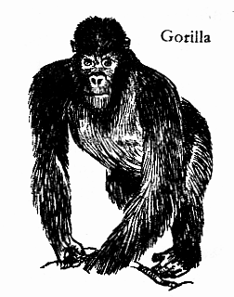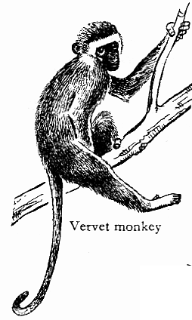

A bush baby A gorilla A monkey

Egg – laying mammals (monotremes)

* These are mammals which reproduce by means of laying eggs.
* They are also called mammals because they feed their young ones on milk from mammary glands.

**Examples of monotremes include;**

There are only two examples of monotremes namely; duck billed platypus and spiny anteater (echidna)

**Illustrations showing monotremes**

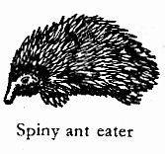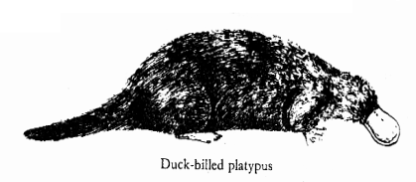

Duck billed platypus Spiny anteater

1. **Learners’ Activity** What is meant by the term monotremes
2. Give any two examples of monotremes
3. State any two reasons why primates differ from other mammals
4. Explain why monotremes are grouped under mammals

5.In which way is duck billed platypus similar to a spiny anteater

**SUBTOPIC: VERTEBRATES (MAMMALS)**

**LESSON 12 : FLYING MAMMALS (CHIROPTERA)**

**Chiroptera (flying mammals**)

* These are the only mammals that fly.
* They have fold skin attached to the fore limbs which act as wings. Bats are the only true examples of chiropteras.

**There are three types of bats namely**;

* Fruit eaters or foresters.
* Insect eaters.
* Blood suckers (vampires)

Note; Bats are nocturnal animals i.e they are more active during the night.

* Bats use echoes to locate their food at

night and dodge obstacles on flying.

**Importance of bats in the environment**.

* Fruit eating bats help in seed dispersal.
* Insect eating bats help to eat harmful insects in the environment that may cause harm to people such as mosquitoes etc.

**Disadvantages of bats**.

* Vampire bats suck blood from animals which may cause anaemia to the animal and even death.
* Waste materials from bats cause a bad smell in a living house.

**An illustration showing a bat flying.**

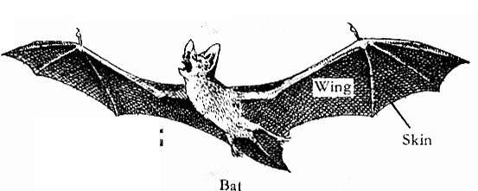

**Learners’ Activity**

1. State any one example of a flying mammal
2. Name the three types of bats
3. Of what importance are echoes to bats?
4. In one sentence state how bats are useful in our environment
5. How can vampire bats be dangerous to animals
6. In one sentence state a reason why bats are regarded as mammals

**SUBTOPIC: VERTEBRATES (MAMMALS)**

**LESSON 13; POUCHED MAMMALS (MARSUPIALS)**

**Pouched mammals**;

* These are mammals with pockets on their abdomen inside where mammary glands are found.
* They are commonly found in Australia and South Africa.

Examples of pouched mammals include;

Kangaroo, koalabear, wallabies, opossums

**An illustration showing a kangaroo with its young one.**

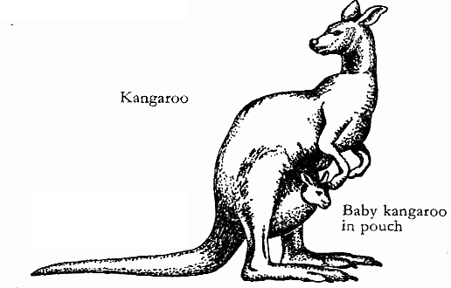

**Note**; The word marsupial means a pouch or a bag

* A kangaroo can leap or jump a great distance.

**Learners’ Activity**

1. Apart from kangaroos give any two other example of pouched mammals
2. Explain why Marsupials are called mammals
3. State two ways in which marsupials are adapted to their mode of life

**SUBTOPIC; VERTEBRATES (MAMMALS)**

**LESSON 14; FLESH EATING MAMMALS (CARNIVORES)**

**Flesh eating mammals (carnivores)**

These are sub groups of mammals with well developed canine teeth and feed on flesh.

**Characteristics of fresh eating mammals.**

* They have sharp claws for holding, killing and tearing their prey.
* They have soft pads feet to enable them run after their prey without making noise.
* They have a good speed, sense of smelling and vision even at night.

**Groups of carnivores include;**

Carnivores are sub divided into two divisions namely;

1. **Cat family**; these have features of the domestic cat.

Examples include; lion, cheetah, leopard, tiger etc.

1. **Dog family**; these are carnivores with specific features to that of a domestic dog.

Examples include, domestic dog, hyena. Jackals. Fox etc

**An illustration showing the skull of a dog**.

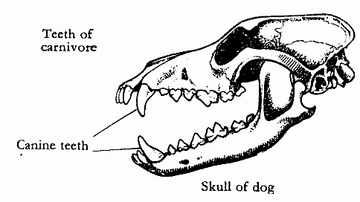

**Note**; Some carnivores are scavenger and therefore feed on flesh killed by other carnivores.

* Carnivores are also called preying mammals and are predators.

A predator is an animal that hunts and kills its prey.

**Learners’ Activity**

1. Explain the term carnivores
2. State two ways in which carnivorous animals are adapted to their mode of feeding
3. Give any two ways in which scavengers are useful in the environment
4. Identify a group a carnivorous animals in which the the following animals belong
5. Leopard
6. Domestic dog
7. State one difference between a preying mammal and a predator

**SUBTOPIC: VERTEBRATES (MAMMALS)**

**LESSON 15. SEA MAMMALS (CETACEANA)**

**Sea mammals;**

These are mammals which commonly live in water of seas and oceans.

**Characteristics of sea mammals**

* They breathe through the lungs.
* They reproduce by means of giving birth and feeding their young ones on milk from mammary glands.
* They have fur on their bodies.

**Examples of sea mammals.**

Whale, dolphins, porpoise, seals and dugongs.

**Note**; whales are divided in to two namely, blue whale and sperm whale.

* A whale is the largest mammal. A whale is over 30m long and over 150 tones in weight .The whale is not a fish.
* A thin layer of blubber insulates the body against heat loss and it is an important food store.
* Whales are hunted by people for their high quality oil.

**Drawn structures showing different examples of sea mammals.**

A whale Dolphin Seals Porpoise

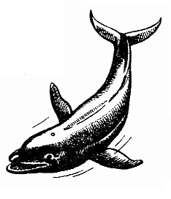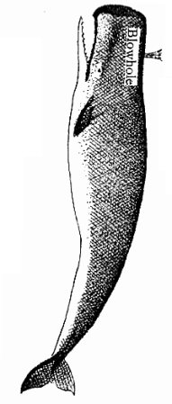

* Sea mammals have some features similar to that of fish.
* All sea mammals are vertebrates and are warm blooded.

**Learners’ Activity**

1. In one sentence explain the meaning of the word sea mammals
2. List any three examples of sea mammals
3. Write any two characteristics of sea mammals
4. Name the largest mammal
5. Of what importance is thin layer of blubber to a whale?

**SUBTIPOC; VERTEBRATES (MAMMALS)**

**LESSON 16: GNAWING MAMMALS (RODENTS)**

**Gnawing mammals (rodents)**

* These are mammals with well developed incisor teeth and chew rapidly.

**Examples of rodents include;**

* Rabbits
* Rats
* Squirrels
* Porcupine
* Mice
* Moles
* Bearers

**Characteristic of rodents.**

* They have well developed incisor teeth for biting and chewing rapidly.
* They don’t have canine teeth.
* Most gnawing mammals are vegeterians therefore, feed on vegetables.
* Most rodents are small in size for easy running very fast.
* Most rodents make holes in soil called burrows for protection and as a habitat.
* They have sharp strong claws for digging up root crops.

**Disadvantages of rodents to crop farmers.**

* All rodents are crop pests.
* They destroy farmer’s crops by causing damage to them.
* Some destroy stored harvested crops in the granaries especially the rats..

**Drawn structure showing a rat and a squirrel.**

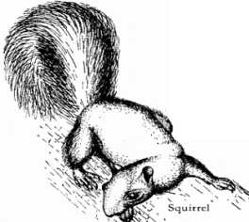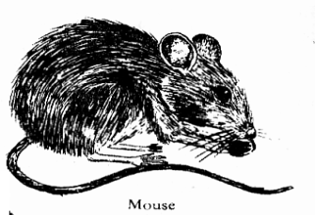

A rat A squirrel

**Learners’ Activity**

1. Write one sentence to explain the meaning of the word gnawing mammal
2. List any four characteristics of gnawing mammals
3. Give three ways in which rodents are a disadvantage to a crop farmer
4. State how rodents are adapted to their mode of feeding

**SUBTOPIC: VEGETERIANS (MAMMALS)**

**LESSON 17: UNGULATES (HOOFED MAMMALS)**

**Ungulates (hoofed mammals)**

These are mammals which feed on vegetables and have hooves on their toes.

**Characteristics of ungulates or hoofed mammals**.

1. They mainly feed on plant materials.
2. They have toes divided into two namely.
3. Even toed , ungulates e.g cow, goat, sheep. Deer, camel etc
4. Odd toed ungulates e.g elephant, horse, zebra, donkey etc.
5. Some ungulates are ruminant and chew cud.
6. Ruminant ungulates have four chambered stomachs.
7. Some ungulates do not chew cud and have one true stomach.

**Note:** cud is food an animal brings back from the stomach to chew again. This is called rumination. Ruminant animals are animals with four chambered stomachs and chew cud. e.g goats, sheep etc.

**Diagram of a ruminant animal**

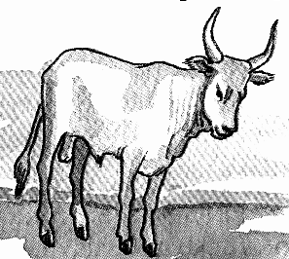

Examples of non- ruminant animals are, hippopotamus, pigs and warthogs.

**Drawn structures showing different toes of ungulates.**

**Horse Cow Camel**

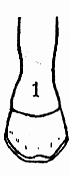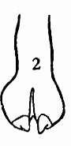

**Elephant**

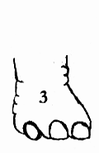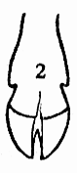

**Insectivores**.

* These are mammals that feed on insects.
* Most of them are nocturnal.

Examples of insectivores include;

-hedgehog – Antbear

-Porcupine – Shrew.

**Things to note:**

* A hedge hog stops and hides its head it curls or rolls into a ball for protection.
* A porcupine has spines for protection.

**Learners activity**

1. State any two characteristics of ungulates
2. How are odd toed ungulates different from even toed ungulates
3. In one sentence explain the term ruminants
4. Give two examples of ruminant animals
5. How does a porcupine protect its self.

**SUBTOPIC: VERTEBRATES (COLD BLOODED)**

**LESSON 18: REPTILES (SNAKES)**

**Reptiles.**

* Reptiles are animals which move by crawling
* The word reptile comes from reptalia meaning crawlers.
* Reptiles commonly live in warm countries.

**Characteristics of reptiles.**

* All reptiles are cold blooded (poikilothermic)
* Reptiles breathe through their lungs.
* They reproduce by means of laying eggs fertilized internally.
* All reptiles have their bodies covered with scales.
* They have three chambered heart i.e two atria and one ventrical.

**Groups of reptiles.**

The main groups of reptiles include , snakes, lizards, tortoises, alligators, crocodiles.

**Snakes.**

* Snakes are groups of reptiles with no limbs and move by gliding/slithering/crawling caused by contraction of their muscles.
* They moult to grow a new skin and increase in size.
* They have a forked tongue which acts as a sense organ for smell and touch.
* Snakes commonly move with their tongues out for protection and easy trapping of its prey.

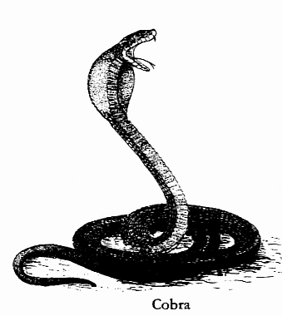

* Snakes are carnivorous animals.

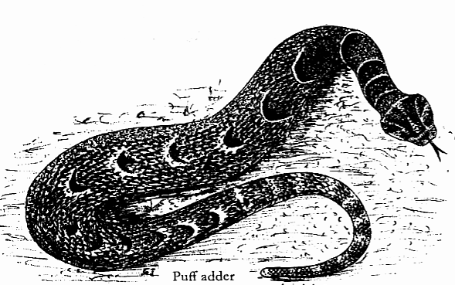

**Diagrams of different snakes**

**Note**; Moulting is the removal of the outer old skin to allow the snake grow a new skin and increase in size.

**Classification of snakes**;

Snakes are grouped or classified according to their features and adaptations

There are basically three groups of snakes. These are;

* Poisonous snakes
* Non-poisonous snakes
* Constrictors.

**Learners activity**

1. In One sentence explain the term reptiles.
2. Give any two characteristics of reptiles
3. Identify any two groups of reptiles.
4. In a sentence, state what is meant by the term moulting as used in reptiles
5. State any one structural difference between poisonous and non poisonous snakes .

**SUBTOPIC: COLD BLOOD VERTEBRATES (REPTILES)**

**LESSON 19: POISONOUS AND NON-POISONOUS SNAKES.**

**Poisonous snakes;**

* These are groups of snakes with poison glands and fangs.
* They have a pair of long hollow teeth (fangs) connected to the poison glands.
* When snakes bite, they inject their poison in the bitten area of the animal. This poison from snakes is called venom.
* Snake venom can be used to make serum used for providing treatment against snake bites.

**Effect of snake poison on blood.**

* Venom lowers the temperature of blood thus clotting it, once clotted, the part affected is cut off (amputated).

**Diagram show a head of a poisonous snake**

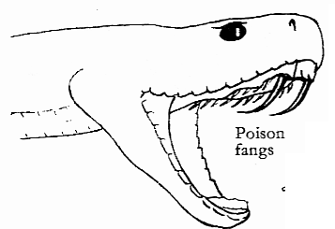

**Note:** each type of a poisonous snake has different types of venom.

Some snakes have their poison gland situated at the back on the mouth with others near the front part of the mouth.

**First aid for snake bites**.

* Calm the casualty
* Identify the fang marks.
* Tie slightly above the bitten part.
* Take the casualty to the nearest health unit.

**Examples of poisonous snakes.**

Cobra, black mamba, puff udder, Gabon viper

**Non-poisonous snakes**.

* These are groups of snakes with fangs with no venom.
* They kill their prey by suffocating them to death

**Examples;** Green snakes, brown house snake.

Note; Non-poisonous snakes help to feed on other organisms such as fogs, rats and mice.

* Constrictors are snakes with developed fangs.
* They kill their prey by crushing and suffocating them.
* They lick their prey making it slippery for easy swallowing.

**Examples include**; pythons, anaconda, boa.

Note: the jaws of a snake are specially constructed to enable them to swallow their prey much larger than their width.

**Learners activity**

1. How does a poisonous snake differ from non poisonous snake
2. State any three characteristics of poisonous snakes.
3. Give two examples of poisonous snakes.
4. How does venom affect blood?
5. What first aid would you give to a P.2 boy who has been bitten by a snake?

**SUBTOPIC: COLD VERTEBRATES (REPTILES)**

**LESSON 20: CROCODILES AND ALLIGATORS**.

**Crocodiles and alligators.**

* Crocodiles are the largest reptiles.
* They are very lazy and lethargic
* They have a long strong jaw for feeding on some aquatic animals.
* They have a long powerful tail for swimming and attacking their prey.
* The female lay hard-shelled eggs in sand or mud.
* Alligators have similar features to the crocodiles however, they live in big waters.

**An illustration showing a crocodile**.

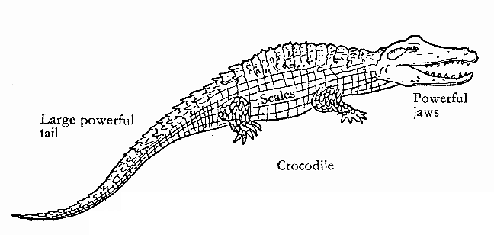

**Tortoises and Turtles/Terrapins.**

Tortoises are reptiles enclosed in a complete hard shell made of bony plates.

* They do not have teeth but have sharp cutting edges for proper digestion of their food.
* They withdraw and hide in their hard shell incase of danger.
* Turtles have flippers for easy swimming in water
* All tortoises/terrapins and turtles use lungs for breathing.
* They reproduce by means of laying eggs commonly laid in sand.
* Tortoises commonly live on land while turtles live in muddy waters.

**Structure showing a tortoise and a turtle.**

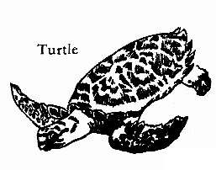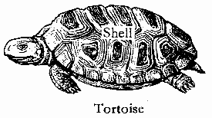

A tortoise with hard shell Turtle with flipper for swimming

**Note;** some tortoise eat plants while others eat small insects.

**Learners activity**

1. Identify any one habitat for crocodiles.
2. State any two characteristics of crocodiles
3. How are crocodiles and alligators adapted to swimming?
4. In two sentences, state how a tortoise is adapted to its mode of life.
5. State how reptiles reproduce

**SUBTOPIC: COLD BLOODED VERTEBRATES (REPTILES)**

**LESSON 21. LIZARDS AND CHAMELEONS**

**Lizards:**

Lizards have two pairs of limbs i.e front and hind limbs for movements.

**Groups of lizards include**:

Common lizards, geckoes and chameleons.

**Characteristics of lizards.**

* They have a fleshy forked tongue for easy trapping of their prey.
* They have movable eye lids.
* They moult to grow new skins and increase in size.
* Geckoes are commonly found in houses and move up side down the ceilings.
* They have suction pads on their feet to enable them walk upside down the ceilings.
* A chameleon has building eyes close to the top of its head to see in all directions back, sideways and forward)
* Chameleons feed on insects such as mosquitoes, house flies using its sticky forked tongue.
* Chameleons camouflage to protect themselves from enemies and easy location of their food.

**Diagrams of a common lizard and chameleon**

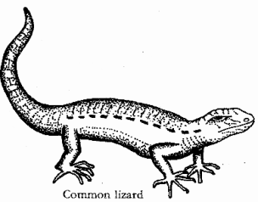

**Common Lizard Chameleon**

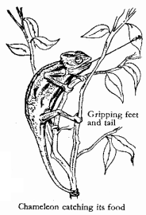

**Importance of reptiles.**

* Some reptiles are sources of food to some people.
* Snakes provide skins for making leather.
* Reptiles attract tourists from other foreign countries.
* Reptiles help to eat harmful insects in the environment.

**Learners activity**

1. List two examples of lizards
2. In four sentences, explain how lizards are adapted to their mode of life.
3. State how a chameleon protects its self against danger.
4. State how geckoes are adapted to moving upside down the ceilings
5. Give any two importance of reptiles to people

**SUBTOPIC: COLD BLOODED VERTEBRATES(AMPHIBIANS)**

**LESSON 22: CHARACTERISTICS OF AMPHIBIANS**.

**Amphibians;**

* Are cold blooded vertebrates that live both on land and in water.
* Amphibians are adapted for early life on water and later life on land.

**Examples of amphibians.**

These include toads, newts, frogs and salamander.

**Characteristics of amphibians**.

* On land they use lungs while in water they use moist skin to breathe.
* They live both on land and in water.
* All amphibians are cold blooded animals (poikilothermic)
* They reproduce by means of laying eggs fertilized externally.
* They have webbed feet for easy swimming in water.
* Their young ones called tadpole have a tail and breathe through gills like fish.
* A newt and a salamander have tails compared to a frog and a toad.
* They have back bones.

**A structure showing external features of a toad**.

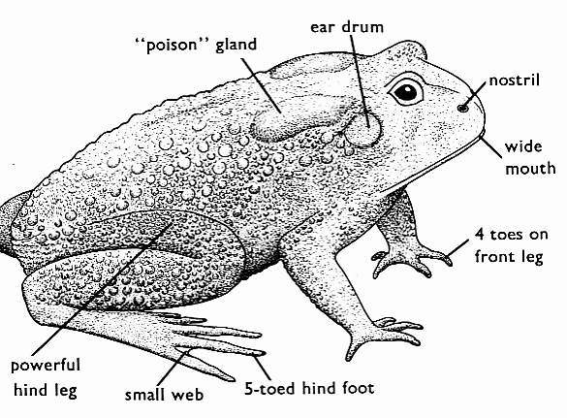

**Differences between a frog and a toad**

**Frog Toad**

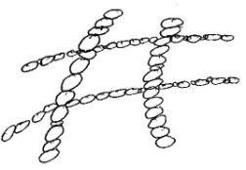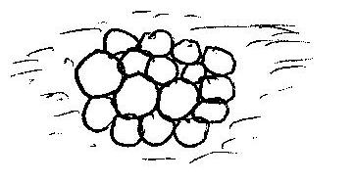

**Frog:** Lay eggs in big masses (cluster) batches

**Toad:** Lay eggs in a double ribbon like structure called spawn.

**Frog:** Breathes through their moist skin and the lungs

**Toad:**Breathes through lungs only

**Frog:**Commonly live in water at late stages.

**Toad:**Commonly live in water at early stages and on land at late stages.

**Frog:**Have long flexible hind legs to make long jumps

**Toad:**Have short hind legs and make short jumps

**A frog**: has a smooth shinny skin with no poison glands.

**A toad:** has a rough warty skin with poison glands

**Learners activity**

1. In one sentence, explain the term amphibian
2. Give two example of amphibians
3. State two characteristics of amphibians
4. State any three differences between a frog and a toad.
5. How does a newt similar to the salamander

**SUBTOPIC: COLD BLOODED VERTEBRATES (AMPHIBIANS)**

**LESSON 23. RESPIRATION IN AMPHIBIANS**

**How amphibians respire.**

* A frog breathes through its moist skin and mouth cavity in water and lungs for breathing on land.
* A frog keeps its skin moist by secretions from the mucus glands.
* A toad also uses lungs and mouth cavity for breathing.
* Amphibians do not have diaphragms and ribs.
* A tadpole uses external gills for breathing.

**Movement;**

* The hind limbs of amphibians are used for crawling and leaping.
* The front legs of amphibians are used for absorbing pressure of the shock of landing.

**Feeding;**

* Adult frogs and toads are carnivorous as they feed on worms, beetles, cockroaches, houseflies and other insects.
* Sometimes toads and frogs leap towards an insect and trap it using their sticky tongues.
* A tadpole is herbivorous and feeds on plants in water.

**Note:** Toads and frogs hibernate, a state when the body activities are slowed down e.g feeding. This is also called **Aestivation.**

**Adaptations of** **a frog to living in water.**

* Frogs have streamlined bodies to enable them move easily in water.
* Frogs have fully webbed hind feet for swimming in water.
* Frogs use their skins and mouth cavity for breathing while in water.
* Frogs can close nostrils when under water to prevent water from entering into the body.

1. **Learners activity** In one sentence, state how amphibians respire
2. How are the hind limbs of amphibians adapted for movement?
3. State how the following amphibians obtain food.

i). adult frogs and toads

ii). Tadpoles

1. In a sentence, explain the term aestivation.
2. In three sentences, state how a frog is adapted to living in water.

**SUBTOPIC: COLD BLOODED VERTEBRATES (FISH)**

**LESSON 24: CHARACTERISTICS OF FISH**

**Fish.**

**Characteristics of fish;**

* They reproduce by means of laying eggs fertilized externally on water.
* They use their fins for swimming in water.
* They are cold blooded vertebrates and breathe in dissolved oxygen in water using gills.
* A young fish is called a **fry**.

**An illustration showing the external parts of a fish.**

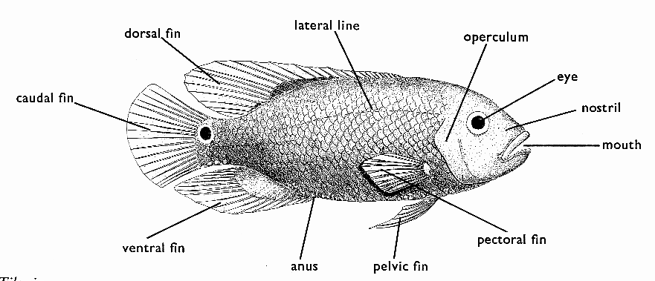

**Functions of the parts.**

**Scales -** covers the body of the fish.

**Gill cover** - Protect the gills from external damage. Its also called operculum

**Nostril –** for smelling and tasting food.

**Tail fin** – For steering on swimming or changing directions.

* It’s also called the caudal fin.

**Dorsal fin** – for protection against predators/defence.

**Pectoral and pelvic fins**. – For slowing down or stopping or act as brakes during swimming.

**Mouth**; is a passage of food and water with dissolved oxygen to the gills.

**Lateral line** – detects sound waves in water.

**Learners activity**

Below is a diagram of a fish. Use it to answer the questions that follow;

A

B

C

D

F

E

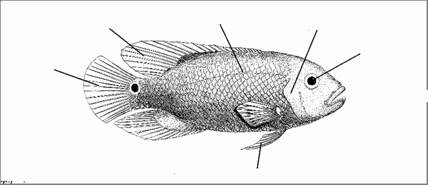

a]. name part B ,C, D

b]. state the functions of parts marked F, A and E

1. What name is given to the young fish?
2. State the type of fertilization that occurs in fish.

**SUBTOPIC: COLD BLOODED VERTEBRATED (FISH)**

**LESSON 25: TYPES OF FISH**

**Types of fish**.

There are basically three types of fish namely;

* Bony fish
* Cartilaginous fish
* Lung fish

**Bony fish.**

These are fishes with a bony skeleton and covered with overlapping scales.

**Examples include;**

Tilapia, nile perch, herrings, Solomon fish.

**Cartilaginous fish**

These are fish with no true bones but just soft bones called the cartilage.

They do not have a swim bladder and gill covers.

Examples of cartilaginous fish are;

Shark, dog fish, rays, skates.

**Lung fish;**

These are fish commonly found in dirty waters of pools, Swamps and rivers.

The commonly hibernate during the dry season and continue living in wet season.

**Examples of lung fish include;**

Emmamba, epiceratodus, are the common examples of lung fish.

**Diagrams showing different types of fish**

**Bony fish Cartilaginous fish Lung fish**

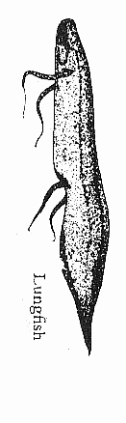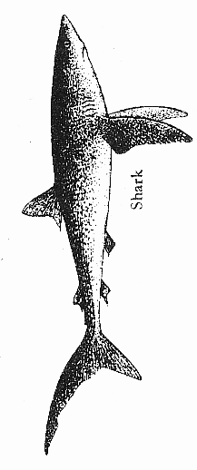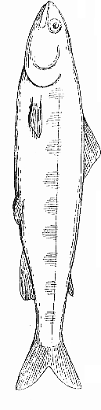

**Reproduction in fish.**

* Female fish lay eggs in shallow water where the male sheds sperm over them.
* Fish undergo external fertilization.

Many eggs are laid but only a few hatch and develop into adults.

**Note;** most fish do not take care of their young one except the tilapia fish.

**Learners activity**

1. Identify any two types of fish
2. How does a fish reproduce?
3. Give two examples of cartilaginous fish.
4. Which fish cares for its young ones?

**SUBTOPICS: COLD BLOODED VERTEBRATES (FISH)**

**LESSON 26: BREATHING OF THE FISH.**

Breathing system of a fish.

* Fish breathe in dissolved oxygen using gills.
* Dissolved oxygen in water is allowed to enter through the mouth cavity and trapped by the gill filament.
* Gill rakes help to trap any foreign body that enters with water to avoid damaging the filaments.
* Gill bar helps to hold the gill filament.
* Gaseous exchange takes place in the gill filament.
* A fish has a number of gill filaments to increase the surface area for respiration (intake of oxygen).

**Note**: A fish will die shortly in case it is removed from water due to lack of dissolved oxygen.

**An illustration showing parts of the gills**.

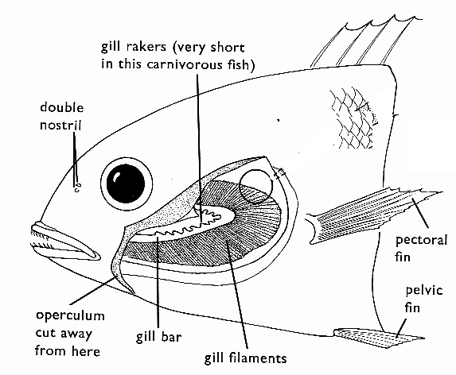

**Adaptations of the fish to living in water.**

* Fish use gills for breathing.
* They are stream lined for easily swimming in water.
* Fish use swim bladder for buoyancy in water.
* Some fish are slippery to escape easy from their enemies.
* Fish have lateral line to detect sound waves in water.
* They have fins for easy swimming in water.

**Learners activity**

1. State how a fish breathe
2. In the space below, draw a structure of a gill and name the following parts;

i]. gill raker. ii] gill bar iii] gill filament

1. State any two ways how a fish is adapted to living in aquatic environment

**SUBTOPIC: INVETEBRATES**

**LESSON 27: GROUPS OF INVERTERBRATES (Coelenterates, sponges and echinoderms)**

**Invertebrates;**

* These are animals with no back bone or vertebral column/spine.
* Most have got an exo-skeleton and do moult.

**Groups of invertebrates**

These are basically six groups of invertebrates namely;

Coelenterates, molluscs, Echinoderms and sponges, worms and Arthropods.

**Coelenterates.**

* These are stinging animals with one body opening.
* Their opening works as both the mouth and Anus surrounded by tentacles.

**Examples of coelenterates includes**;

Hydra, jerry fish, sea anemones and corals

Echinoderms and sponges

* These are animals which live in seas.

Examples include, star fish, sea urchin and sea cucumbers

**An illustration showing a star fish**

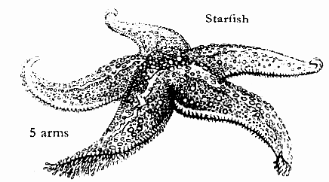

* Sponges also live in fresh water and commonly live in colonies.
* They breathe and feed through many holes on their bodies.
* Food and oxygen are absorbed as water flows through their holes on the body.

**Learners activity**

1. Explain the term invertebrates in one sentence
2. Identify any two groups of invertebrates
3. Give two examples of each group of invertebrates in (2) above.
4. What characteristic is shared by all invertebrates
5. How does a star fish obtain its food.

**SUBTOPIC: INVERTEBRATES.**

**LESON 28: MOLLUSCS.**

**Molluscs;**

These are invertebrates which are soft bodied and usually protected by a shell.

They live in shells in seas and other fresh water bodies. Some of them live on land.

**Examples of molluscs**.

Oyster, octopus, cuttlefish, garden snail, water snail, slugs, squids.

* The garden snail and slugs live on land.
* They have tentacles for detecting sound, smell and temperature.
* Sea molluscs have gills for breathing while land molluscs use simple lungs.

**Illustrations showing different examples of molluscs**

Slug Garden snail

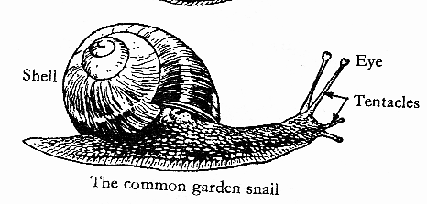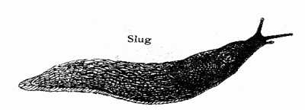

oyster Octopus

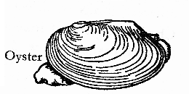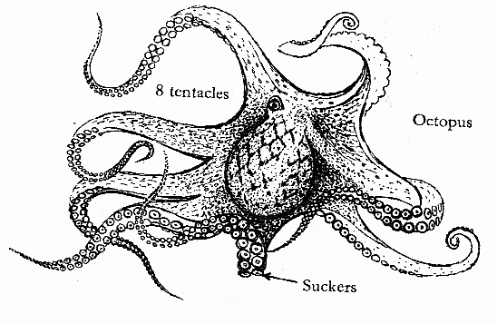

**Dangers of molluscs to people.**

* Fresh water molluscs are vectors to people.
* They spread worms that cause bilharzia.
* This worm is called schistosome.

**Learners activity**

1. State what is meant by the term molluscs
2. Write any three examples of molluscs
3. State two ways in which some molluscs are dangerous to human health.
4. Draw and name parts of a garden snail.

**SUBTOPIC: INVERTEBRATES (WORMS)**

**LESSON 29: SEGMENTED WORMS.**

**Worms;**

* These are long thin and soft bodied invertebrates.
* They use their moist skins for breathing.
* They have hydrostatic type of skeleton.

**Categories of worms**

* worms are grouped into three major groups namely:
* segmented worm (annelids)
* round worms (nematodes)
* flat worms.

**Segmented worm**:

These are worms with segmented bodied or rings. they mostly live in most places.

Examples of segmented worms **include:**

An earthworm, bristle worm and leech.

Earth worms feed on plant materials.

Below are diagrams showing an earthworm and a leech

earthworm leech

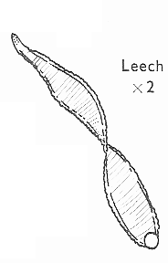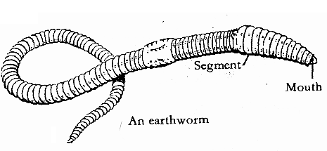

**Note;** An earthworm is a hermaphrodite. i.e have both female and male reproductive organs.

* Earth worms help in aeration of soil as they make channels in the soil.
* Earth worms come out of the soil when it has rained to breath in oxygen.
* Earth worms also soften the soil.
* Their excreta help in the formation of humus sub-groups

**How earthworms move**.

Earth worm move by contraction of their body muscles.

**Learners activity**

1. what are segmented worms
2. Give two examples of segmented worms
3. Identify any other two groups of worms apart from segmented worms
4. Why do earth worms come out of the soil when it has rained
5. State the importance of earth worms to a farmer

**SUB TOPIC: INVERTEBRATES(WORMS)**

**LESSON 30**

**FLAT WORMS.**

**Flat worms:**

* These are worms with flattened and segmented bodies made up of three layers.
* They are parasites to animals and live in the animals’ intestine.
* They feed on animals digested food.

**Examples of flat worms.**

* Tape worm, liver flukes.
* tape worms live in the small intestines in animals and feed on the digested food
* They have the hooks to attach themselves on the walls of the stomach.
* They have the suckers for sucking digested food from the stomach walls.
* Their bodies are covered with mucus to prevent themselves from hot substances sent to the stomach.
* Liver flukes are paper like and live in the liver of the affected animal causing damage to it.

1. **Diagram showing parts of a tape worm**.

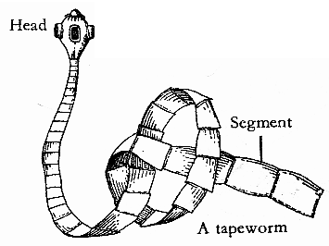

1. **Diagram of a liver fluke.**

**Learners activity**

1. List two examples of tape worms
2. How do tape worms enter into our bodies
3. State the dangers of having tape worms in our bodies
4. Give any one way of avoiding tape worm infestation
5. Draw and name parts of a tape worm (i.e. segment, Suckers, hooks.

**SUBTOLPIC: INVERTEBRATES.**

**LESSON: 31**

**ROUND WORMS**

**round worms**

* These are groups of worms with a cylindrical body.
* They are also parasites to animals and people**.**
* Some live in water and others in soil.
* The commonest type of round worms lives in animal’s small intestine and usually seen through faeces of infected animals.

**Examples of round worms**

* hook worms
* pin worms
* guinea worms
* ascaris worms
* filatial worms
* eel worms
* Thread worms.

**How hook worms enter our body?**

* by penetrating through soles of our feet when we walk bare-footed, especially in dirty places.
* they enter through the skin and stay in the small intestine sucking blood.
* as they suck blood, they cause anaemia to the host.

**a diagram of a hookworm**

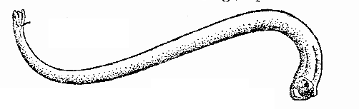

**Dangers of worms to people**

* They suck blood hence causing anaemia.

**ways of preventing hook worm infection**

* By wearing scandals/shoes when visiting dump places such as latrines.
* By washing hands after visiting a latrine.
* By washing fruits before eating them in raw form.
* Through proper disposal of human wastes.

**Learners activity**

1. Outline the characteristics of hook worms
2. List any two examples of hook worms
3. Identify ways by which hook worms enter into our bodies
4. State any one way in which worms are dangerous to people.
5. State any three ways of preventing hook worm infection

**sub-topic: invertebrates**

**lesson 32 : single-celled invertebrates**

**single celled animals:**

* These are very tiny (microscopic) animals whose bodies are made up of a cell-membrane, cytoplasm and a nucleus.
* They are also known as unicellular organisms.
* Such single-celled animals are called protozoa.
* Many of them are found living in ponds, ditches, seas, lakes, rivers and inside bodies of other animals.
* They are too small to seen by our naked eyes. Therefore they are observed through an instrument called microscope.

**Examples of Single-Celled Animals**

* Amoeba
* paramecium
* plasmodia
* Chlamydia
* trypanosomes
* schistosomes etc.

**Structures of an Amoeba and Paramecium**

amoeba paramecium

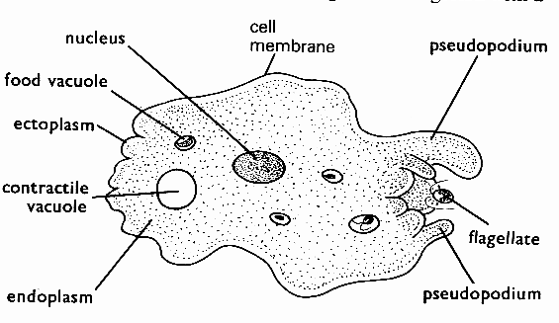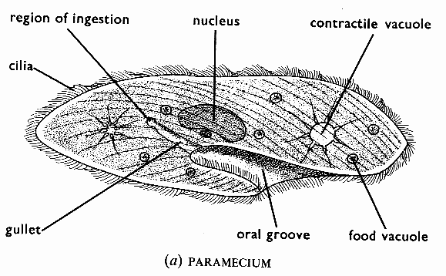

**Characteristics of an amoeba.**

* They live in water to protect them against drying up.
* They reproduce by cell-division.
* They feed by engulfing food particles.
* They move by means of pseudopodia (false legs).
* They are single-celled-unicellular in nature.

**Characteristic of a Paramecium.**

* It is a unicellular organism.
* It has a nucleus, cell membrane and cytoplasm.
* It moves by means of cilia.
* It also reproduces by cell-division.
* Its body is covered by cilia.

**Dangers of Protozoa.**

* Most protozoa cause diseases to people. e.g.
* Amoeba- amoebic dysentery.
* plasmodia- malaria
* Chlamydia- bilharzias
* Trypanosomes- sleeping sickness to people and nagana to live stock.

**Learners activity**

1. In one sentence, explain the term single celled animals
2. Name any three examples of single celled animals
3. How does an amoeba obtain its food?
4. Draw the structure of an amoeba and name the parts; nucleus, pseudopodium and cell membrane.
5. State any one way in which protozoa are dangerous to people

**Sub topic: invertebrates (arthropods)**

**Lesson 33:**

**Groups arthropods (myriapods)**

**Arthropods:**

These are animals with jointed legs and segmented bodies.

* Their bodies are covered with an exo-skeleton.
* The exo skeleton controls their growth and size.
* Arthropods do moult to remove their exo-skeleton in order to grow a new one and increase in size.

**Sub groups of arthropods.**

Arthropods are sub divided into four sub groups. myriapods, arachnids, crustaceans, insects.

**Myriapods;**

Myriapods are arthropods with many jointed legs with an exo-skeleton.

Examples of myriapods include millipedes and centipedes.

**Diagram showing a centipede and millipede.**

Centipede Millipede

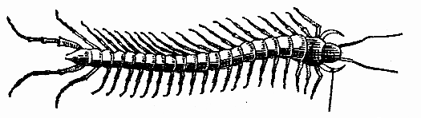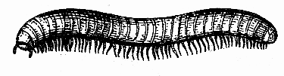

* A centipede has one pair of jointed legs on each segment.
* A centipede is a carnivore and feeds on insects and other small worms.
* A centipede has poison glands which produce poison used to inject in its prey and for protection.
* A millipede is a herbivore and makes holes in soil hence helping in soil aeration.
* A millipede protects itself from enemies by curving up into a ball like structure/by coiling.
* Some small millipedes produce a smelly fluid for protection.
* They also roll on their backs when disturbed to scare their enemies

**Similarities between centipedes and millipedes**

* Both have jointed legs on each segment
* Both have an exoskeleton
* Both roll on their backs when disturbed to scare their enemies

**Differences between centipedes and millipedes**

* A centipede is a carnivore while a millipede is a herbivore
* Unlike a centipede a millipede has more legs
* A centipede has poison glands for protection while a millipede protects itself by coiling

**Learners activity**

1. What are arthropods?
2. Mention the different groups of arthropods.
3. List any two characteristics of arthropods
4. In two sentences, state how a centipede is similar to a millipede
5. How does a millipede protect itself from enemies

**Subtopic: invertebrates (arthropods)**

**Lesson 34:**

**Groups of arthropods (arachnids)**

**Arachnids**

* These are arthropods which have four pairs of legs.

**Characteristics of arachnids.**

1. Have no antennae.
2. Have two main body parts (head and abdomen).
3. Have four pairs of legs – eight legs.
4. Have a simple eye and also compound eyes.

**Examples of arachnids include**

Ticks, scorpions and spiders.

**Spiders**

* Spiders are commonly seen on walls of houses.
* They use book lungs for breathing
* They make webs for their nests and also for trapping prey.
* Spiders are carnivorous, trap small insects and suck their fluids for food.
* The males also use the web to trap the females for mating.

**Reasons why spiders are not classified as insects**.

* They have two main body parts instead of three
* Spiders have for pairs of jointed legs instead of three.
* Spiders use book lungs for breathing while insects use spiracles.

**Scorpion**

* A scorpion has a large tail with poison which it injects into its enemies after stinging them.
* A scorpion produces live young ones.

**Ticks**

Ticks suck blood from animal hence spreading tick borne diseases to animals.

**Examples of tick borne disease include**:

East coast fever, red water, heart water, anaplasmosis.

They are all caused by protozoa spread by ticks to cattle.

**Note:**

Tick borne diseases can be controlled on the farm by:

* Dipping and spraying the animals with acaricides.
* Grazing animals on new pasture.
* By double fencing (best method).

**Drawn structures showing a tick, spider, scorpion and a mite.**

tick scorpion Mite spider

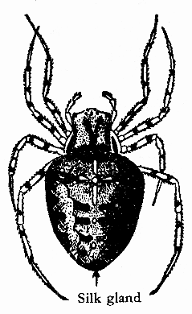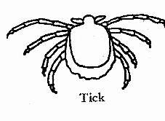

**Learners activity**

1. What are arachnids?
2. List any two characteristics of arachnids.
3. Give two reasons why spiders are not classified as insects
4. Give two examples of tick borne diseases
5. In two sentences, state how a farmer can control spread of tick borne diseases on a farm.

**Sub topic: invertebrates (insects)**

**Lesson 35:**

**Characteristics of insects.**

**Insects**

* These are arthropods with three main body parts.
* They have three pairs of joined legs
* Insects breathe through organs called spiracles located on their abdomen.
* Have one pair of antennae/feelers
* Insects have an exo-skeleton and do moult.

**Examples of insects:**

* Houseflies, tse-tse flies, dragon flies, grasshoppers, cockroaches, moth, bees etc.

**External parts of a housefly.**

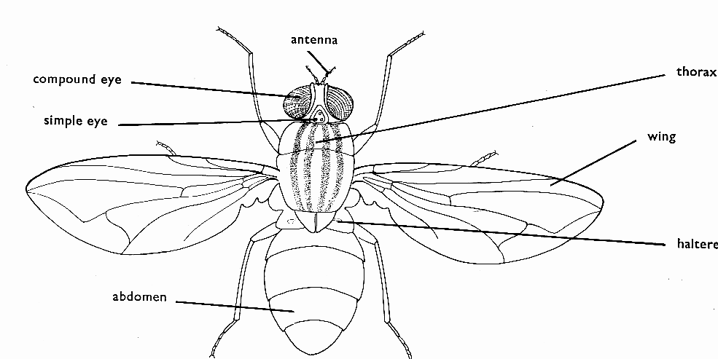

**Function of the above parts.**

1. Compound eyes: used for vision or sight.
2. Antennae: for smelling and feeling.
3. Proboscis: for sucking food or fluids.
4. Mandibles: for chewing its food.
5. Wings: for flying.
6. Halteres: for balancing in air while flying.
7. Spiracles: for gaseous exchange/breathing.

**Importance of the thorax to the insect**

* Provides attachment of wings.
* Is where wings and jointed legs are attached
* Has halteres used by the insect to balance in air during flight.

**Learners activity**

1. List down four characteristics of insects
2. State the function of the following parts of an insect;

i]. antennae ii]. Spiracles iii]. Halters

1. In the space below, show the life cycle of a house fly (diagram)
2. What name if given to the larva of a mosquito?
3. Explain the following terms;

i]. metamorphosis ii]. Moulting

iii]. Incomplete metamorphosis

**Sub-topic: invertebrates (insects)**

**Lesson 36**

**Reproduction in insects.**

**Reproduction in insects**

* most insects reproduce by means of laying eggs.
* there are basically two types of metamorphosis namely complete metamorphosis and incomplete metamorphosis.

**Complete metamorphosis**

This is a type of metamorphosis (complete life cycle) in which an insect undergoes four distinct stages of development.

These include eggs, larva, pupa and adult.

**Note**: the larva stage of a housefly is the most active stage while the pupa stage is the most dormant stage

The larva stage of the following insects ;

* housefly-maggots
* mosquito-wrigglers
* butterflies-caterpillar
* cockroach-nymph

**A diagram showing a complete metamorphosis of a housefly.**

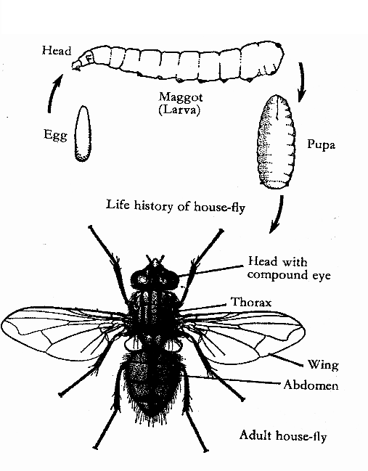

**A diagram showing a complete metamorphosis of a anopheles and culex mosquito.**

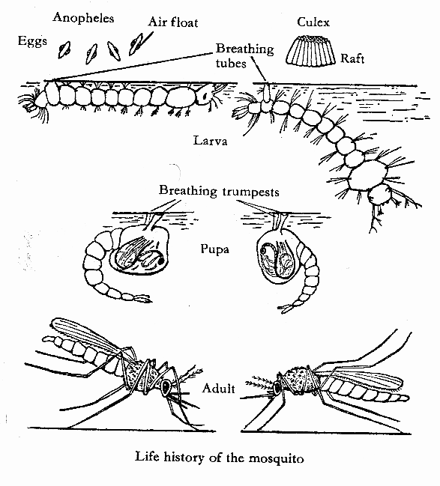

Examples of insects that undergo complete life cycles

Houseflies, mosquitoes, bees, wasps, butterflies, moth.

**Incomplete metamorphosis.**

* This is type of life cycle in which insects undergo three stages of development.

**A diagram showing incomplete metamorphosis of a cockroach**

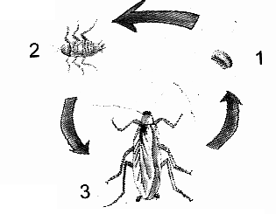

Examples of insects which undergo incomplete metamorphosis, cockroaches, grasshoppers, locusts.

**THEME: MATTER AND ENERGY**

**TOPIC: SOUND ENERGY.**

**LESSON 1 TYPES OF SOUND**.

**Sound**

* Sound is a form of energy produced by vibration of an object.
* Sound is regarded as form of energy because it enables people to do work.
* vibration is the movement of an object to and from or up and down .

**Types of sound**

* Loud sound, soft sound, noise, high and low sound.
* music is an organized sound produced by regular vibrations while noise is sound produced by irregular vibrations.

**Sources of sound**

* A source of sound is where sound waves originate from
* Sound travels through a medium by sound waves.
* Sound travels fastest in solids, faster in liquids and fast in gases.

n.b sound doesn’t travel through a **vacuum**.

Reason; there is **no medium** in a vacuum.

**Natural sources of sound**

These are materials that produce their own sound naturally i.e. sound from birds, animals, thunder and volcanic eruptions.

**Artificial sources of sound.**

These are materials controlled by humus in order to produce sound.

They are mainly musical instruments.

e.g. guitar, drum, brute, keyboard, flute, tube fiddle, xylophones etc.

**How living things produce sound.**

* Mammals produce sound by the vibration of their vocal cords (human change the tongue and the lips to produce sound).
* Birds produce sound by vibration of their rings of cartilage in of the trachea.
* Insects like bees and mosquitoes produce sound by rapid flapping of their wings. grasshoppers and locust produce sound by rubbing their hind legs against their wings.

**Learners’ Activity**

1. In one sentence explain the term sound
2. List two main sources of sound
3. How is sound produced
4. Give a difference between noise and music
5. How does the voice of a human being produce sound

**SUB TOPIC MUSICAL INSTRUMENTS.**

**LESSON 2.**

**GROUPS OF MUSICAL INSTRUCMENTS.**

**Musical instruments**,

* All musical instruments are material used to produce sound.
* They are used to accompany or give a beat to the flow of music.

**Groups of musical instruments.**

There are basically three categories of musical instruments basing on how they produce sound, how they are played and their features.

1. **PERCUSSION MUSICAL INSTRUMENTS**

These are musical instruments which produce sound by vibration of their skins or the wood by beating or hitting them.

**Examples of percussion musical instruments**.

Xylophones, drums, long drum, bells, thumb pianos, brass band, drums, rattles, clappers/strikers.

**Diagrams showing different examples of percussions.**

A long drum A drum Xylophone bell

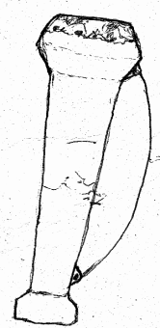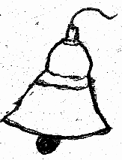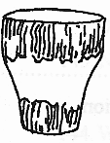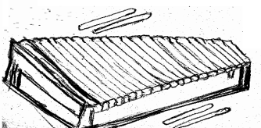

**Note;** pitch of percussion musical instruments can be determined by heating their skin to expand or tightening the skin.

**Learners’ Activity**

1. Write one word to mean instruments that produce sound by hitting
2. List two example of such instruments
3. How does a drum produce sound?
4. In which way drums similar to xylophones
5. In the space below draw one example of a percussion instrument

**SUB TOPIC MUSICAL INSTRUMENTS.**

**LESSON 3.**

**WIND MUSICAL INSTRUMENTS (AEROPHONES).**

**Wind musical instruments**.

* These are musical instruments which produce sound by the vibration of air blown inside them
* Some have holes numbered to produce different pitch of sound. Each hole produces a different pitch of sound.

**Examples of wind musical instruments.**

flute, trumpet, pan pipes, empty bottles, horns etc.

**Learners’ Activity**

1. Why is panpipe called a wind instrument?
2. Apart from panpipes give any two other examples of wind musical instruments
3. How would you change the pitch of sound in a bottle half filled with water?
4. In order to produce a high pitch
5. In order to produce a low pitch
6. In the space below draw and name any one wind musical instrument

**SUBTOPIC MUSICAL INSTRUMENTS.**

**LESSON 4: STRING INSTRUMENTS (CHORDOPHONES)**

**String musical instruments.(chordophones)**

* These are instruments made of strings and produce sound by vibration when they are plucked/bowed.
* They are mainly played by plucking of their strings or by bowing.

Examples of string musical instruments.

Guitar, tube fiddle, lyre, a harp, violin.

**Diagram showing a structure of a bow harp**.

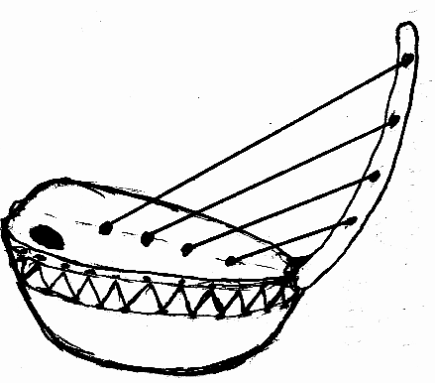

* Strings of a bow harp have different lengths to produce different pitch of sound.
* From the diagram above, string A will produce low pitched sound while string D will produce high pitched sound when bowed.

**Learners’ Activity**

1. Use one sentence to explain string instruments
2. Write two examples of string instruments
3. How does a bow harp produce sound
4. The diagram below show a musical instrument. Use it to answer the questions that follow.

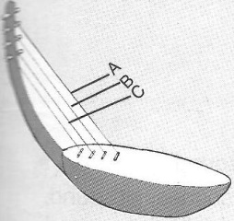

1. Identify the instrument above
2. Identify the string which produces the highest sound
3. Give a reason for your answer

**HOW SOUND TRAVELS**

**LESSON 5**

**SPEED OF SOUND**

**Speed of sound**

* For sound to travel there must be a medium.
* Sound needs a medium to transmit sound waves from the source to the destination.
* A medium should be a state of matter such as solids, liquids and gases.
* Sound travels fastest in solids, faster in liquids and fast in gases.
* The speed of sound in normal air is 330m/sec.

**Class activities:**

1. How sound travels through solids.

Place a watch on one end of a wooden table place your ear on the other end, you will clearly hear the ticking of the clock hands.

1. How sound travels through liquids.

Put a stone in water and hit it using another stone from normal air.

The sound heard in loud showing that sound travels in liquids.

**Factors affecting the speed of sound**.

The following are some of the factors that interrupts the speed of sound.

* Wind, heat (temperature) and altitude.
* wind carries sound waves further to many directions
* Wind can also obstruct the sound waves by blowing it in opposite directions.
* During a hot day, sound waves move at a higher level compared to cold days.
* Sound waves find it easy to move along a lower altitude than going up a hill or mountain.

**Sub topic terms used in sound**

**Lesson 6**

**Echoes:**

**Echoes**

* An echo is a reflected sound formed as a result of obstruction of sound waves.
* Echoes have the same characteristic as the original sound.
* Smooth hard surfaces produce the best echoes while soft surfaces absorb sound.

**Advantages of echoes:**

* Bats use high pitched echoes to trap their prey at night in darkness.
* Bats use echoes to dodge obstacles at night.
* Pilots use echoes from hills, cliffs ends of tall building to avoid accidents.
* Sailors and sea men use echoes to determine the depth of the sea using an echo sounder.

**Disadvantages of echoes.**

* Echoes make sound difficult to interpret.
* Echoes cause accidents and noise pollution.

**How are echoes reduced in cinema halls and theatres**.

* Use of thick curtains.
* Use of porous materials such as soft boards in the speakers.

**Volume of sound**

* Volume is the loudness or softness of sound.
* The volume of sound depends on the amplitude of the vibration produced.
* Amplitude is the width of vibration.

**Frequency**

* Frequency is the number of vibrations produced per second.
* The greater the amplitude, the louder the volume of sound and vise versa.

**Diagram showing frequency produced by different strings**.

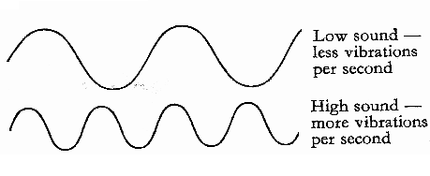

**Learners’ Activity**

1. Explain the term echo
2. Why are echoes produces?
3. How are echoes useful to human beings?
4. State any one danger of echoes in our environment
5. Why are walls and ceilings of cinema halls fitted with soft boards?

**SUBTOPIC: TERMS USED IN SOUND**

**LESSON:7**

**PITCH OF SOUND.**

**Pitch of sound.**

* pitch of sound is the highness or loudness of sound produced
* When objects vibrate, the sound produced can either be high or low.
* Pitch of sound can also be caused due to the amplitude produced.
* The faster the body vibrates, the higher the frequency and sound produced.

**Factors that affect pitch of sound.**

The following are the conditions that may make produced sound heard with a low or high pitch.

* Frequency.
* Tension of the string.
* Surface area for vibration.
* Length of the string.
* The smaller the surface area for vibration, the higher the pitch produced.
* High frequency produces high pitched sound.
* When a string of a musical instrument is short, it will produce high pitched sound.

**An experiment showing pitch of sound.**

Bell A Bell B Bell C

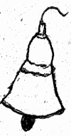

**Observation:**

Bell A: Will produce sound of the highest pitch.

Bell B: produced low pitched.

Bell C: will produce the lowest pitched sound.

**Learners’ Activity**

1. Which term refers to the highness or lowness of sound?
2. Mention one factor that determine the pitch of sound.
3. How can you change the pitch of sound of a string instrument
4. State the two ways of storing sound
5. Mention any one way of reproducing stored sound

**Sub topic: the mammalian ear**

**Lesson:8**

**Structure of the mammalian ear.**

**Human ear.**

The human ear is a sensory organ used for hearing sound.

The ear also helps in balancing the body in the right position.

**Parts of the ear.**

The ear is divided into three main regions namely.

* The outer ear.
* The middle ear.
* The inner ear.

**The outer ear.**

* The outer ear is made up of the pinna and auditory canal. The pinna helps to trap or collect sound waves and direct them to the auditory canal.
* In the outer ear, there is hair to trap dust and other foreign bodies before damaging the ear drum.
* The ear drum is made up of a thin soft membrane sensitive to sound waves.
* it vibrates according to the pattern of sound waves received from the vibrating object.

**The middle ear.**

This consists of the three bones called the ossicles. i.e malleus (hammer), incus (anvil) and stapes (stirrup).

The ossicles amplify and transmit the vibrations produced by the ear drum across the middle ear to the inner ear.

It also contains the Eustachian tube to balance air pressure between the ear and atmospheric pressure.

**The inner ear.**

* This consists of the cochlea, semi-circular canals and the auditory nerves.
* The cochlea contains two fluids i.e perilymph and endolymph to convert sound vibrations into impulses.
* The auditory nerve helps to carry sound impulses to the brain for interpretation.
* The semi-circular canals help to balance the body in a right posture.

**Diagram showing the parts of the human ear.**

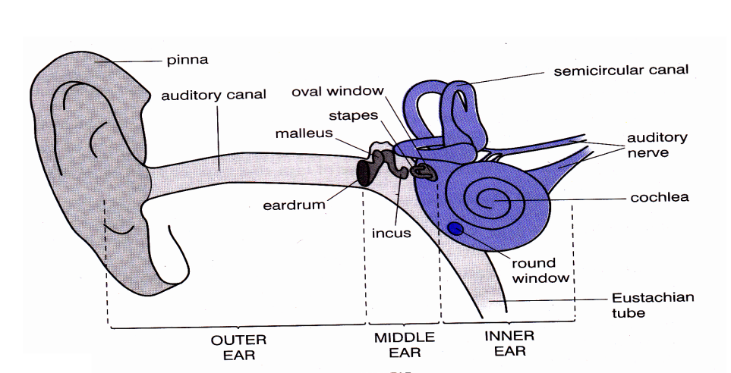

**Learners’ Activity**

1. The diagram below show the human ear. Use it to answer the questions that follow.

Q

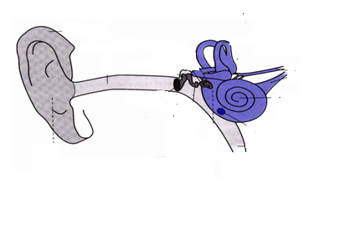

R

P

1. Name the parts labeled P and R
2. What general name is given the structures labeled Q?
3. State the function of the pinna
4. Apart from hearing, give any one other function of the ear.
5. State two ways of caring to the human ear
6. In a sentence, give a difference between a partial and sensory deafness
7. State how partial deafness can be corrected

**Subtopic: sound devices**

**Lesson :9**

**Storing and reproducing stored sound**

**Devices used in storing sound.**

* Sound devices are materials used when recording and reproducing sound.
* We can store sound either by recording it on sound devices or writing it in solfa notation.
* We need to store sound for future use.

**Sound devices used to record or store sound include**

* Video Compact Magnetic Tapes.
* Audio Compact Discs (VCDS)
* Digital Video Discs (DVDS)
* Computer Diskettes.
* Audio Compact Discs (cds)

**Devices used to reproduce the stored sound.**

* Stored sound can be reproduced by playing the devices with stored sound in compact magnetic disc players.

**Examples include:**

Radio cassette, video disc players, computer monitor, gramophones/digital video disc player.

**TOPIC: SOUND ENERGY**

**SUB-TOPIC: MAMMALIAN EAR**

**LESSON: 10 DISEASES AND DISORDERS OF THE HUMAN EAR**

**DISEASES OF THE HUMAN EAR:**

1.otitis

2.outer ear -infection

3.inner-ear - infection

**DISORDERS OF THE HUMAN EAR:**

1. Foreign body in the human ear. e.g seeds/grain/soil/insects/chemicals.
2. Deafness-inability to hear.

* It is caused by infection if not detected early.
* can be through in heritance
* Others by damaging the ear drum after piercing it with a sharp object.

**Types of deafness**

**Disorder (defect)**

**Effect**

**correction**

1. partial deafness

Un ability to hear

Removing the wax by syringing

1. sensory deafness caused by old age, infections serious skill fracture

-Unable to differentiate between sounds

-a person hears but cannot understand.

-By good feeding to keep healthy even at old age

-Avoid travelling in vehicle which are under bad mechanical conditions

-treatment of any infection as soon as the symptoms are noticed.

1. permanent deafness

A person is totally unable to hear any sounds.

-common in damp people

Cannot be corrected

Care for the human ear:

* eating a balanced diet to keep healthy.
* avoid staying near noisy places.
* treat infections as soon as symptoms are sighted
* avoid pushing sharp/piercing object into the ear.
* clean the ear daily with clean water and soap.

Compare the human ear with the organs of other animals used for hearing e.g. the snake, fish, insects, amphibians, birds.

**Theme: the human body.**

**Topic: circulatory system.**

**Subtopic: components of the circulatory system.**

**LESSON: 1**

**Components of the circulatory system.**

The body consist of seven main systems namely, reproductive, skeletal, digestive, respiratory, nervous, circulatory and excretory systems.

* The circulatory system is also called the transport system of the body.
* It involves the supply of body cells with fluids in the body.
* Components of the circulatory system are the features that connect to allow smooth flow of the body fluids.

**Diagram showing the main blood circulation**

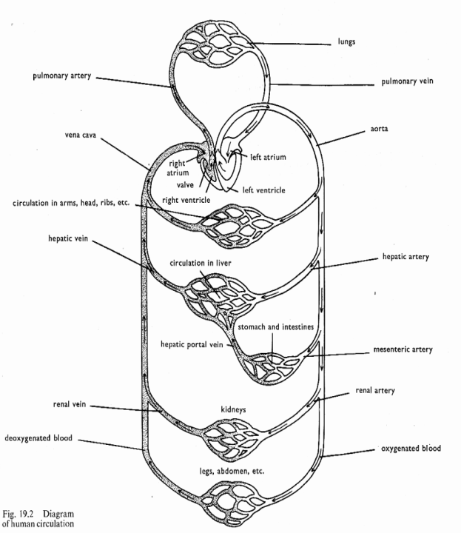

These are the heart, blood, blood vessels.

The heart;

* The heart is the main organ in mammalian body pump continuously blood to all body parts.
* Its enclosed in the thorax in a tough membrane called pericardium.
* The heart has four chambers, the two upper chambers and two lower chambers.
* the heart is made up of cardiac muscles

**The structure of the human heart.**

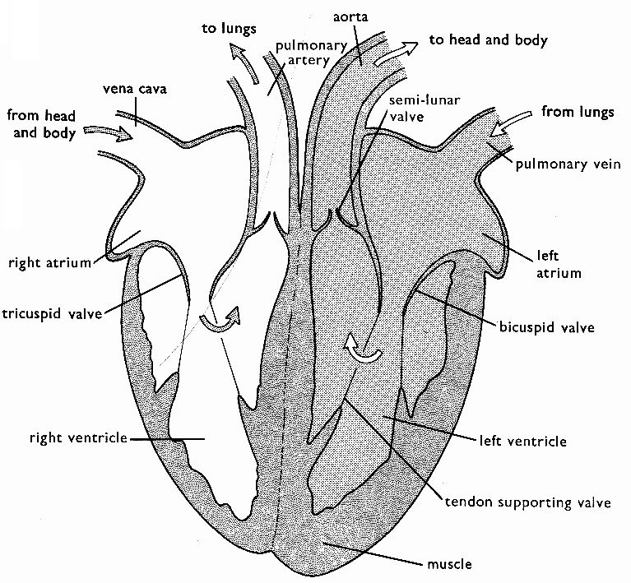

**Note**; the heart is protected by the ribcage and the normal pumping of the heart is 72 times per sec

**Learners’ Activity**

1. Name the main organs of the circulatory system.
2. List the three blood vessels of the circulatory system
3. Apart from the red blood cells mention any other two components of blood.
4. What is the role of valves in veins
5. Identify any one disease of the circulatory system

**Subtopic: the human heart**

**Lesson 2:**

**How the heart works**

**How the heart works;**

Circulation of blood in the heart is supported by four main vessels. These are;

**Vena cava, pulmonary artery, pulmonary vein and aorta**.

**Vena cava:** it receives blood with less oxygen called deoxygenated blood from all parts of the body to the heart.

* Blood is then pushed down from the right upper auricle, to the ventricle and then to the lungs via the pulmonary artery.
* Blood visits the lungs to pick oxygen and drop off carbondioxide.
* Oxygenated blood (blood with more oxygen) is then carried back to the heart through the pulmonary vein to be pumped to all parts of the body through the aorta.
* The heart has valves to prevent backward flow of blood in the heart.
* It also separated into two sides by the septum to avoid de-oxygenated blood from mixing with the oxygenated blood from mixing with the oxygenated blood.
* The left part of the heart is made up of thick walls due to its resistance to high blood pressure.
* Doctors are able to listen to the flow of blood or heart beat using an instrument called **stethoscope** and **asplymometer** for the blood pressure.

**Learners’ Activity**

1. List the two upper chambers of the heart
2. Which blood vessel leads blood from the body to the heart
3. Which part of the heart pumps blood to the lungs
4. Why is the left ventricle wall thicker than the right ventricle wall
5. Why does blood flow to the lungs before it is supplied to the rest of the body parts?

**Subtopic: blood**

**Lesson : 3.**

**Components of blood.**

**Blood.**

* Blood is the red liquid that flows continuously in the body.
* It becomes bright red when oxygenated and dark red when de-oxygenated.

**Components of blood.**

Blood component are

* platelets (thrombocytes)
* plasma (fluid of blood)
* white blood cells (leucocytes)
* red blood cells (erythrocytes)

**Note:** an adult person has a capacity of 5-6 liters of blood in the body.

**Red blood cells.**

These are blood components made of circular disc shapes and oxygen.

* They are made in the red bone marrows of short bones.
* They appear red due to the existence of the haemoglobin.
* When the haemoglobin combines with oxygen it forms oxy-haemoglobin blood which is reddish bright in colour.

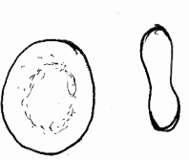

Diagram of a red blood cell

**FUNCTION OF RED BLOOD CELLS.**

* Helps to carry oxygen around the body.

**Note:** Plasmodia parasites attack the red blood cells hence causing malaria to the people.

**Subtopic: blood components**

**Lesson: 4**

**Plasma and white blood cells**

**Blood plasma**

* It’s the liquid or watery part of blood
* It’s pale in colour.

**Components of plasma.**

* Blood proteins, digested food, hormones and mineral salts, water.
* Blood plasma transports carbondioxide from all body parts to the lungs.
* blood plasma transports digested food to all parts of the body
* Blood plasma also transport hormones from the glands to where they are needed.

**White blood cells.(leucocytes)**

These are blood cells with a nucleus but with no haemoglobin in their cytoplasma.

Nuclear

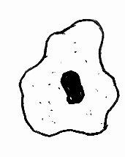

* White blood cells are commonly made from lymph nodes the spleen and grey bone of long bones.
* They help to fight against diseases causing germs in the body by engulfing and producing more anti bodies.
* The white blood cells have an irregular shape to enable them engulf the germs.

**Blood platelets. (thrombocytes)**

* Blood platelets are also made in the red bone marrows.
* They help to reduce over bleeding by clotting around the wound.
* They are very many in the body with no nucleus and live shortly.

**Diagrams showing different blood cells**



**Note**; shortage of blood platelets result into uncontrolled bleeding in case of a wound.

* Too many white blood cells in the body may cause a disease called leukaemia.

**Learners’ Activity**

1. How useful are the following components of blood in the body?
2. Red blood cells
3. White blood cells
4. Platelets
5. Blood plasma
6. Identify a disease that attacks the following
7. Red blood cells
8. White blood cells

**LESSON: 5**

**SUBTOPIC: BLOOD GROUPS.**

**Blood groups**

* Blood is group according to the presence of antigens A or B in the red blood cells.
* there are basically four different blood groups

blood group A

blood group B

blood group AB

blood group O

* When a person bleeds and becomes anaemic victim needs to replace the lost blood. This can be done through blood transfusion.
* Blood transfusion is the transfer of screened blood from one person of the same group to another.
* A person who receives the donated blood is then called a blood recipient.
* One who gives out blood is called blood donor.
* A universal recipient is a person who can receive blood from any other blood group, however can donate blood to persons with blood group AB.
* blood group O is also called a universal blood donor because can donate blood to any other blood group but receives blood from blood group O only
* Blood before transfusion should be screened and stored safely in the blood bank.
* In Uganda it’s done at Nakasero blood bank.

**Lesson: 6**

**Subtopic: blood vessels**

**Arteries and veins.**

**Blood vessels;**

* Blood vessels are muscular tubes that help in proper circulation in the human body
* They run from the heart to all other parts of the body.

**Types of blood vessels.**

There are basically three types of blood vessels namely arteries, veins and capillaries.

**Arteries.**

* Arteries are mainly blood vessels that carry blood away from the heart.
* They have thick walls and narrow blood passage or lumen.
* They lack valves.
* Blood in arteries flow at a high pressure.

**The structure of an artery**

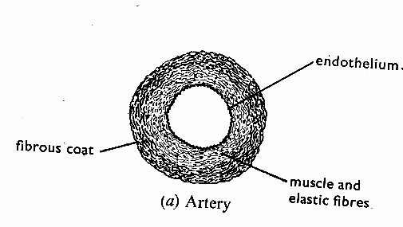

**Note:** most arteries carry oxygenated blood except pulmonary artery

**Veins:**

These blood vessels that carry blood towards the heart.

* they have valve, wider lumen and thin walls
* Valves in veins open in one direction to prevent back ward flow of blood.
* Blood in vein flows at a low pressure.

**Capillaries**

* These are the smallest blood vessels that help to connect the veins to arteries.
* Capillaries help to allow the exchange of blood materials.
* All veins carry deoxygenated blood except the pulmonary vein.
* the pulmonary vein carry oxygenated blood

**Structures showing veins and blood capillaries.**

vein Blood capillaries

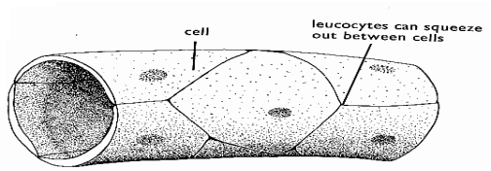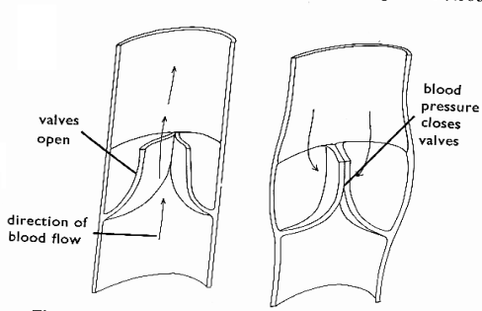

**Note:** the aorta is the biggest artery while the vena cava is the biggest vein in the body.

**Learners’ Activity**

1. Identify any two blood groups
2. Give the functions of the following blood vessels
3. Arteries b) Veins
4. Give any two structural differences between arteries and veins
5. State any one functional difference between arteries and veins

**DISEASES OF THE CIRCULATORY SYSTEM**

**LESSON 7**

**BLOOD AND HEART DISEASES**

**Blood diseases**

These are disease which commonly attacks the blood components,

* Malaria, leukaemia, anemia, haemophilia, HIV, diabetes and sickle cell anaemia.

**Diseases that attack the heart.**

These include

* thrombosis
* heart attack
* hypertension
* Anaemia is caused due to lack of iron in one’s diet.
* Iron helps in the formation of haemoglobin which easily combines with the oxygen in the red blood cells.
* Sickle cell anaemia is a condition when one’s red blood cells are single celled and therefore unable to carry enough oxygen around the body.
* Haemophilia is condition in which one’s blood is unable to clot in case of an injury.
* Leukaemia is blood cancer which makes the number of white blood cells abnormally higher.
* Malaria is caused by plasmodia germs spread by female anopheles mosquito.

These commonly attack and destroy the red blood cells.

**Heart diseases;**

These are diseases that mainly affect the normal functioning of the heart.

They include; coronary thrombosis, hypertension and heart attack.

**Coronary thrombosis**

This is a disease that affects the heart and is caused due to the blockage of the coronary arteries that supply oxygenated blood and digested food to the heart.

It makes the cardiac muscles weak and may stop working due to limited oxygen and digested food supply.

**Hypertension.**

This is a disease of the walls of the arteries making or reducing their lumen.

This caused mainly due to smoking of poisonous drugs contained in tobacco.

The poisonous drugs damage the cardiac muscles reducing their functioning.

**Diabetes;**

This is caused due to the presence of too much glucose in the body.

This disease commonly affects people who feed on a lot of sugary foods and do not do heavy work to burn the glucose in the body.

**Learners’ Activity**

1. Write four diseases of the circulatory system
2. Identify one vector disease of the circulatory system
3. Mention one circulatory disease which affects white blood cells
4. Mention one cause of heart diseases
5. Suggest one way of improving proper functioning of the circulatory system.

**Sub topic: Diseases of the circulatory system**

**Lesson: 8**

**HIV and AIDS**

**hiv and aids**

* hiv and aids is a disease that affect the circulatory system.
* hiv stands for : Human Immunodeficiency Virus
* aids stands for : Acquired Immune Deficiency Syndrome
* This disease attacks one’s immune system making the body lack defense to infections.
* The victim’s body becomes weak or unable to defend itself from infections due to the destroyed white blood cells.
* hiv does not kill the victim, it’s the secondary infections untreated that kill the victim.

**Ways through which hiv and AIDS is spread.**

* Having unprotected sex with an infected person.
* Sharing skin piercing objects with an infected person.
* Through transfusion of unscreened blood.
* Through some cultural practices such as circumcision.

**Effects of AIDS.**

* Having makes one’s immunity destroyed resulting into easy attack by infection.
* AIDS causes death of the victim.
* A family or community can easily lose an important person in case of death.
* AIDS has led to orphans and increased number on street children.

**Ways of controlling the spread of hiv and aids.**

* having protected sex with trusted sex partners
* avoid sharing skin piercing objects with an infected person
* Through transfusion using screed blood.
* Avoid sharing knives during cultural practices such as circumcision/ tattooing.

**note:** aids Victims should be given a lot of care by encouraging them to promote personal hygiene, feed well and take their drugs in time. Tuberculosis victims are mistaken to be HIV victims due to the same signs and symptoms.

**Learners’ Activity**

1. Write the following in full

i) HIV ii) AIDS

1. Identify the cause of AIDS
2. suggest two ways in which AIDS is spread
3. Why are adolescent girls at a higher risk of getting HIV and AIDS than boys of the same age group
4. Suggest a piece of advice adolescent boys and girls for the prevention of HIV and AIDS
5. List two disorders of the circulatory system.
6. Suggest one way of increasing the volume of blood circulation in the body.

**topic: circulatory system**

**sub-topic: heart disorders**

**lesson 9: disorders of the circulatory system/care of the heart**

Disorders of the circulatory system

* cuts
* strings
* burns
* scalds
* Hiccups.

**Care of the organs of the circulatory system**

* Eating a balanced diet.
* doing regulatory physical exercises
* Regular visits to hospital for medical check up
* Avoid eating too fatty/oil food stuffs.
* Avoid rough games.
* Take much care to accidents.

**Ways of Increasing volume of Blood in Circulation**

* Eating a balanced diet.
* Eating foods mainly rich in iron e.g. greens, animal liver and kidneys
* Taking ferrous tablets with advice from a medical worker.

**Theme human health**

**Topic: alcohol in our society**

**Lesson 1**

**Subtopic: types of alcohol.**

**Alcohol:**

Alcohol is a chemical substance that makes people drunk once taken in.

**Types of alcohol.**

There are basically two types of alcohol namely;

* Ethyl (ethanol) alcohol
* Methyl (methanol) alcohol

***Ethyl (alcohol)*** is the most common type of alcohol found in alcoholic drinks.

It’s the type of alcohol formed immediately after the ripening of a plant fruit.

Plant fruits ripen due to ethylene hormone.

***Methyl alcohol*** ( e.g. methanol) is the most dangerous type of alcohol.

It can easily cause blindness in case of contact with the eyes.

**Examples of alcoholic drinks include:**

‘malwa’,’tonto’ and beer.

**Reasons why people drink alcohol.**

People drink alcohol for a number of reasons

* People drink alcohol due to excitement or happiness
* To celebrate their successes
* To forget their problems
* To quench thirst

**Learners activity**

1. In one sentence, explain the term alcohol.
2. Identify any two examples of alcoholic drinks
3. Mention the two main types of alcohol.
4. Give any two reasons why people take alcohol

**Subtopic alcohol and alcoholism.**

**Lesson 2:**

**Methods of producing alcohol.**

**Methods of producing alcohol**.

There are basically two methods of producing alcohol namely;

* Fermentation method.
* Distillation method

**Fermentation method.**

Fermentation is the process of turning sugar from plant juice and water into alcohol

This is aided by yeast

The sugar found in fruit juice is worked upon by yeast to form fermented alcohol.

**Example of plant materials used to produce fermented alcohol are;**

Ripe banana, cassava flour, maize, millet, sorghum

**Distillation method**.

* This is a process of obtaining pure alcohol from fermented alcohol by boiling evaporating and condensing of the alcohol vapour to form distillate
* Distillation method involves two process namely evaporation and condensation of the vaporised alcohol into a liquid.
* The liquid obtained using this method is called a distillate.
* Examples of alcoholic drinks obtained through this method are waragi, enguli, kasese, liralira whisky, rum gin, vodka.

**Diagram showing distillation method of making alcohol**.

Delivery tube



* Heat source provides the heat to cause evaporation.
* Cold water helps to condense the vapourised alcohol into a liquid.
* Note: home distillation of alcohol is illegal due to the likely
* Accidents that may occur.

**Learners activity**

1. In one sentence, explain each of the following terms;

a] fermentation b] distillation

1. State the importance of each of the following during distillation;

a] cold water ii] heat source

1. In one sentence, give a reason why home distillation of alcohol is illegal.
2. Give any three examples of plant local materials used to produce fermented alcohol
3. Define the term distillate

**Topic; alcohol and alcoholism**

**Lesson;3**

**alcoholics and alcoholism**

**Uses of alcohol in the society.**

* Alcohol is an important drug in the society recommended on most celebrations.
* Alcohol (methyl alcohol) is used by doctors to sterilize medical instruments that cannot be boiled on cleaning.
* Alcohol can be used in some thermometers.
* Alcohol (methylated spirit) can be used to clean the skin before an injection is taken.
* Alcohol is also used as a disinfectant on wounds.
* Alcohol can be used by builders to mix paints and dyes.

**Alcoholism.**

* This is a condition that results from the prolonged use of alcohol.
* It results into the body’s addiction to alcohol.
* It also makes the body functioning controlled by the alcohol in take.
* The person who is who is addicted to taking alcohol for his or her normal body functioning is called an alcoholic.

**Factors that may lead one to take alcohol**

* Stress
* Sad news
* Peer pressure
* Family background or life styles.
* Seductive advertisement.

**Learners activity**

1. Explain the following terms;

a] alcoholic b] alcoholism

1. Mention any three factors that may lead to alcoholism
2. State any two ways in which alcohol is important in the society.
3. State how alcohol affects;

i] an individual ii] the family iii]. The community

1. State the law governing the use of alcohol in Uganda.

**SUBTOPIC: ALCOHOL AND ALCOHOLISM.**

**LESSON: 4**

**EFFECTS OF ALCHOLISM.**

**Effects of alcoholism**.

The habit of taking alcohol causes social and health problems in the society.

These effects are caused to; individuals, family or the community.

1. **Individuals.**

The following are the effects that may result from alcoholism to an individual.

* It causes damages to body organs such as, liver, brain and stomach walls
* Leads to personal neglect .(self neglect)
* Leads to loss of appetite for food resulting into stomach ulcers.
* Leads to poverty since most of the money is spent on buying a alcohol.

1. **To the family;**

The following are effects that can be caused in case one of the family members is an alcoholic.

* Family poverty.
* Family neglect.
* Loss of family respect.
* Antisocial behavior, child abuse, separation of spouses.
* Causes immorality in children.

**c)** **To the community.**

* Alcoholism leads to road accidents by drivers working under the influence of alcohol.
* Alcoholism also leads to increased crime rates in the community.
* Alcoholic officials delay community services since most times they are drunk.

**Laws governing alcohol in Uganda**.

* Persons below 18yrs of age are not allowed to drunk alcohol in public places.
* All public places dealing in alcohol should be licensed after fulfilling certain standards.
* Drivers are not allowed to drive under the influence of alcohol.
* All forms of home distillations, transportation and possession of alcohol is illegal.

**SUBTOPIC: SMOKING**

**LESSON: 5**

**TYPES OF SMOKING**

**Smoking**

* This is the regular use of tobacco by a person.

**Commonly smoked drugs:**

* Njaga, marijuana, Bhangi.
* opium.
* cocaine. it is sniffed through the nose.
* Tobacco. This contains Nicotine and tar.

**Ways people use tobacco include;**

* Through the burning pipes.
* Through burning cigarettes.
* By sniffing tobacco powder.
* By chewing the leaves of tobacco.

**Note;** tobacco contains a dangerous gas called carbon monoxide and dangerous chemicals namely Nicotine and Tar.

**Types of smoking**.

There are two types of smoking namely,

* Active smoking.
* Passive smoking.

Active smoking is the act of inhaling tobacco smoke directly from a burning cigarette.

Passive smoking is the act of inhaling air contaminated by tobacco smoke from an active smoker.

**Reasons why people smoke;**

People have different reasons why they smoke

* Some smoke to warm their bodies.
* Some smoke due to peer pressure.
* Some smoke to concentrate on their work.
* Some smoke to feel confident.
* Some smoke to look sophisticated/ important.

**SUBTOPIC: SMOKING**

**LESSON: 6**

**EFFFECTS OF SMOKING**.

**Effects of smoking.**

* Tobacco smoking is harmful to one’s health.
* Tobacco contains poisonous chemicals and a gas.

These are nicotine, tar and carbon monoxide gas.

**Disease caused due to smoking.**

Diseases that result from smoking affect the respiratory system. they include;

* Lung cancer, emphysema, tuberculosis.
* Tuberculosis, bronchitis and pneumonic are worsened by smoking.

Smoking is also dangerous to pregnant mother in the following ways;

* Causes miscarriage/abortion.
* Causes pre mature birth/ still birth.
* Causes under weight births.

**Effects of smoking to the community.**

* Smoking can easily result into fire out breaks in an area.
* Smoking causes air pollution.
* It creates bad practices among children in the area.

**Effects of smoking to the family.**

* All family members become passive smokers.
* Young children copy bad habits from elders who smoke.
* It can also lead to loss of family income since much of the money used for smoking.

**How to avoid smoking**.

* Keeping busy during free time by involving in football, volleyball, and music to avoid thinking about smoking.
* Avoid joining peer groups of people who use tobacco and other drugs.
* Advise friends who smoke about the dangers of smoking.

**Learners activity**

1. Explain the term smoking
2. Identify the different ways people use tobacco
3. Differentiate between passive and active smoking.
4. Give any two reasons why people smoke.
5. State two ways in which smoking can be dangerous to pregnant mother and to the family.
6. Outline any two ways of controlling smoking

**SUBTOPIC: DRUGS IN SOCIETY.**

**LESSSON: 7**

**ESSENTIAL DRUGS.**

**Drugs;**

A drug is any chemical substance introduced in the body that affects the functioning of the body systems.

Drugs can be introduced in the body voluntarily or involuntarily.

**Types of drugs.**

There are basically two types of drugs namely.

* Essential drugs.
* Narcotic drugs.

Narcotic drugs arte drugs which cause addiction after a prolonged use or dependency.

**Examples of narcotic drugs are,**

Tobacco, alcohol, marijuana, opium etc.

**Essential drugs.**

These are drugs used by people to meet their health problems.

* They are categorized into four groups
* Pain killers – for reducing pain.
* Curative drugs – used to cure diseases.
* Preventive drugs commonly vaccines used to prevent diseases
* Contraceptives –mainly used in family planning.

**Qualities/ characteristics of essential drugs.**

The following are the attributes of essential drugs:

* They should be common and affordable.
* They should have less side effects and meet people’s health problems.
* They should have value for money.

**Ways drugs are introduced in the body**.

* By swallowing (tablets)
* By injections (injectables)
* By drinking (syrups)
* By smearing (ointments)

**Learners activity**

1. In one sentence, explain the term drug.
2. Identify the different types of drugs.
3. What are essential drugs?
4. In three sentences, explain the qualities of essential drugs.
5. State any two ways in which essential drugs are introduced in the body

**Topic: drugs.**

**Lesson 8.**

**Subtopic: types of essential drugs.**

**Types of essential drugs:**

Essential drugs are grouped into two types according to their characteristics namely;

* Traditional drugs.
* Laboratory drugs.
* Traditional drugs are drugs which have existed before the introduction of science and technology
* Traditional drugs can also be modernized in the laboraties.

**Examples- blackjack cures wounds**

* ‘bombo’ grass for cough etc.
* ‘enkejje’ for measles

**Characteristics of traditional drugs.**

* They are used in their raw form mainly
* Their side effect on human health is not known.
* Their purity and quality changes.
* They are commonly not packed and sealed.

**Laboratory manufactured drugs.**

These are drugs which are commonly made from the laboratory with both manufactured dates and expiry dates.

**Examples include:**

Cough mixtures, chloroquine, paracetamol, pilton, ORS for rehydration, capsules etc.

These drugs are commonly found in clinics, hospitals and other health units.

**Characteristics of laboratory manufactured drugs**

* They are well packed and scaled to prevent easy contamination.
* Have expiry dates
* Are the same for every quantity made they have labels, names and what they cure.
* Their stability and strengthen are known.
* They have same purity and quality.

**Learners activity**

1. State the difference between traditional drugs and laboratory drugs.
2. Give two examples of traditional drugs.
3. Outline any two characteristics of traditional drugs.
4. List down any three characteristics of laboratory manufactured drugs
5. Give any two examples of laboratory drugs

**Subtopic: drugs in society**

**Lesson 9**

**Drug prescription**

**Drugs prescription;**

This is the written information given by a health worker on how to use a certain drug.

Prescription of drugs is based on the age, weight of the patient, sex or gender and duration or length of illness.

Prescribed drug consists of ; name of the drug the disease it cures, time of taking the drug, the dosage.

**Importance of drug prescription.**

* It prevents people from taking under or over dose.
* It helps the patient to avoid drug misuse.

**Under dosage**; is when ones takes than the recommended

**Drug misuse**; is the act of using a drug with out or against the recommended advice. It is the wrong use of a drug.

**Dangers of buying drugs from shops or markets**.

* Drugs may be harmful or expired.
* Such drugs are not well prescribed and stored.
* Drugs may be contaminated
* They may be spoilt/damaged
* They may be fake drugs.

**Learners activity**

1. Explain the following terms;

i] drug prescription ii] drug misuse

1. Give two reasons why health workers should give drug prescription to their patients.
2. State any two dangers of buying drugs from shops.
3. State any two ways in which people misuse drugs today.

**Subtopic: drugs in society**

**Lesson 10: drug storage and drug abuse.**

**Drug storage.**

* Drugs need to be kept in a clean cool dry place to prevent them from contamination.
* Cold chains are used to keep vaccines where there is no electricity
* Drugs should also be kept away from children to prevent child poisoning at home.

**Dangers of poor storage of drugs.**

* Drugs may easily become contaminated and lose its curative value.
* Poorly stored drugs instead become poisonous to one’s health.
* Keeping drugs in children’s reach can easily cause child poisoning in homes.

**Drug abuse;**

* Is the use of a drug in way that is harmful to one’s health drugs abused can be either legal or illegal.

**Reasons why people abuse drugs.**

* To quench thirst
* To improve performance
* To concentrate on work
* To feel warm
* To celebrate successes.

**Effects of drug abuse;**

* It can cause health damages to the body organs such as the brain, liver pancreas etc.
* Drugs abuse can cause abnormalities or improper body function.
* Drug abuse can easily result into death. It leads to divorce/spouse/child abuse.

**Note;** drugs of dependency are drugs which cause addiction incase of prolonged use.

Drug dependency is when one’s body becomes addicted to a certain drug.

Life skills to safe guard against drug dependency.

* Keeping busy with sports and games in free time
* Avoid peer groups which exercise the use of common drugs.
* Engage in good social clubs.
* Never wish to taste any drug any day.

**Learners activity**

1. What is drug abuse?
2. Why do people abuse drugs?
3. Give any two effects of drug abuse to an individual.
4. Explain what is meant by the term drug dependency.
5. State any two life skills of safe guarding against drug dependency

**END OF TERM ONE WORK**